



SETUP DOCUMENT

LARP EVENT SOFTWARE SOLUTION

Version 2.0

Dholon Akter | Nr. 3047040

Chanelle Hart | Nr. 3323781

Talia Santos | Nr. 3294579

Thanh Hoàng | Nr. 3353362

GROUP 34

# Version History

|  |  |  |  |  |  |
| --- | --- | --- | --- | --- | --- |
| **Version #** | **Implemented By** | **Revision Date** | **Approved By** | **Approval Date** | **Reason** |
| 0.5 | T. Santos | 6th Mar | - | - | Rough draft |
| 0.6 | C. Hart | 9th Mar | - | - |  |
| 1.0 | T. Hoàng | 11th Mar | - | - | Add GUIs, Wireframes, ERD |
| 2.0 | T. Hoàng | 18th Mar | - | - | Finalization |
| 3.0 | T. Santos | 24th Jun | - | - | Touch up, remove old GUI for replacement |

Table of Contents

Version History 2

Agreements 8

Functional Requirements 8

GUI 9

Login forms for all applications 9

Entrance application 9

Manager application 12

Rental Application 15

Entrance application 17

Wireframes 18

Homepage: 18

Story So Far page: 19

Rules page: 20

Events page 21

Activities page: 22

Food, drinks and loaning items page 23

Games page: 24

Camping page: 25

News page: 26

News – read more: 27

About page: 28

Login page: 29

Sign up page: 30

Participant’s information page 31

Participant’s information page 32

Camping registration page: 33

Bundles page: 34

Visual Design 35

Homepage: 35

Story So Far: 36

Rules page: 37

Events page 38

Activities page: 39

Food, drinks and loaning items page 40

Games page: 41

Camping page: 42

News page: 43

News – read more: 44

About page: 45

Login page: 46

Sign up page: 47

Participant’s information page 48

Participant’s information page 49

Camping registration page: 50

Bundles page: 51

ERD 52

# Agreements

**Applications:**

* The applications should have functionalities supporting the management and personnel of the events.
* The applications will run on Windows.
* The applications should be user-friendly and accessible to all personnel and management.
* The applications for stores and loan stands should be self-service.

**Website:**

* The website should have functionalities supporting the purchase tickets and/or reservations of camping spots.
* The website should be visually appealing and informative to potential visitors.
* All personal information on the website will be carefully stored.
* The website will be able to run on mobile devices.

# Functional Requirements

*Table 1. Functional requirements classified.*

|  |  |  |  |  |
| --- | --- | --- | --- | --- |
|  | **Must have** | **Should have** | **Could have** | **Won’t have** |
| **Website** | [WMH1] Website is informative  [WMH2] Website has visual appeal  [WMH3] User can purchase tickets  [WMH4] User can reserve camps  [WMH5] Website stores information safely | [WSH1] Website is responsive on mobile devices | [WCH1] Website can have an about page for the company  [WCH2] Website can have an about page for the events  [WCH3] Website can have room for feedback  [WCH4] Website can have links to social media  [WCH5] Website can have a picture gallery | [WWH1] Website will not process payments |
| **Applications** | [AMH1] Application can monitor visitors: enter, exit and quantity  [AMH2] Application supports selling and loaning items  [AMH3] User can have an overview of the event  [AMH4] Application can handle ATM logs  [AMH5]  Application can run on Windows | [ASH1] Application is user-friendly  [ASH2] Application have manuals | [ACH1] A mobile application for stores and loan stands |  |

# GUI

## Login forms for all applications

All applications require authentication before the user can access the functionalities. Below is how said form would look.

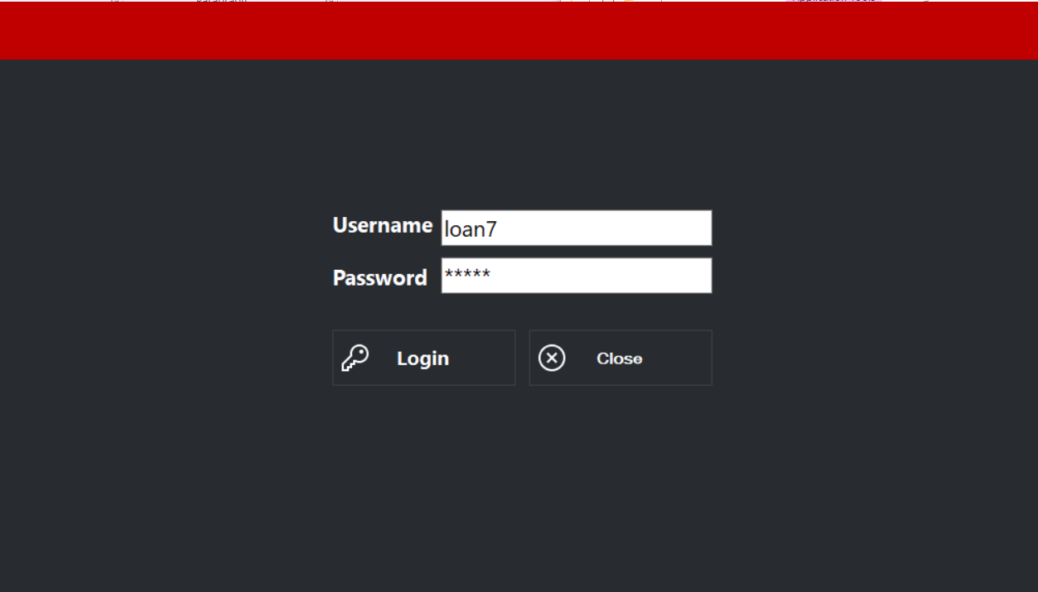

Figure . Login form for all applications

## Entrance application

The entrance application has two sections:

1. Check-in: The section used for scanning and checking in visitors (see Figure 2.1)
2. Logs: The section used to see and/or search relevant data (see Figure 2.2)

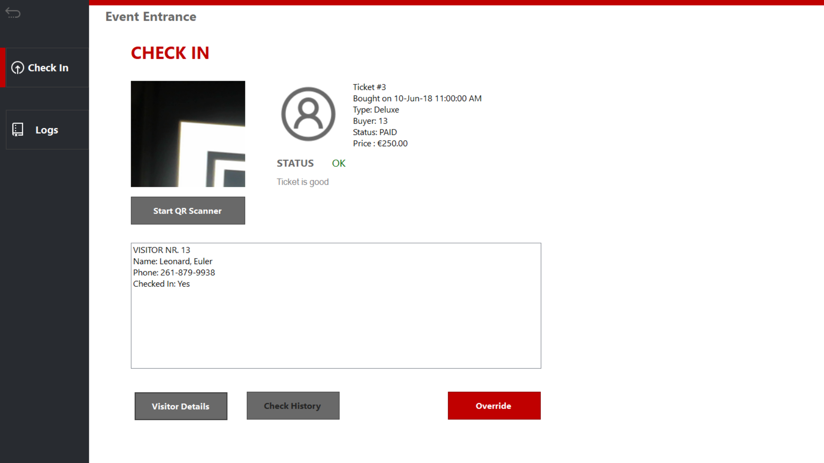

Figure .1 Check-in form for the event

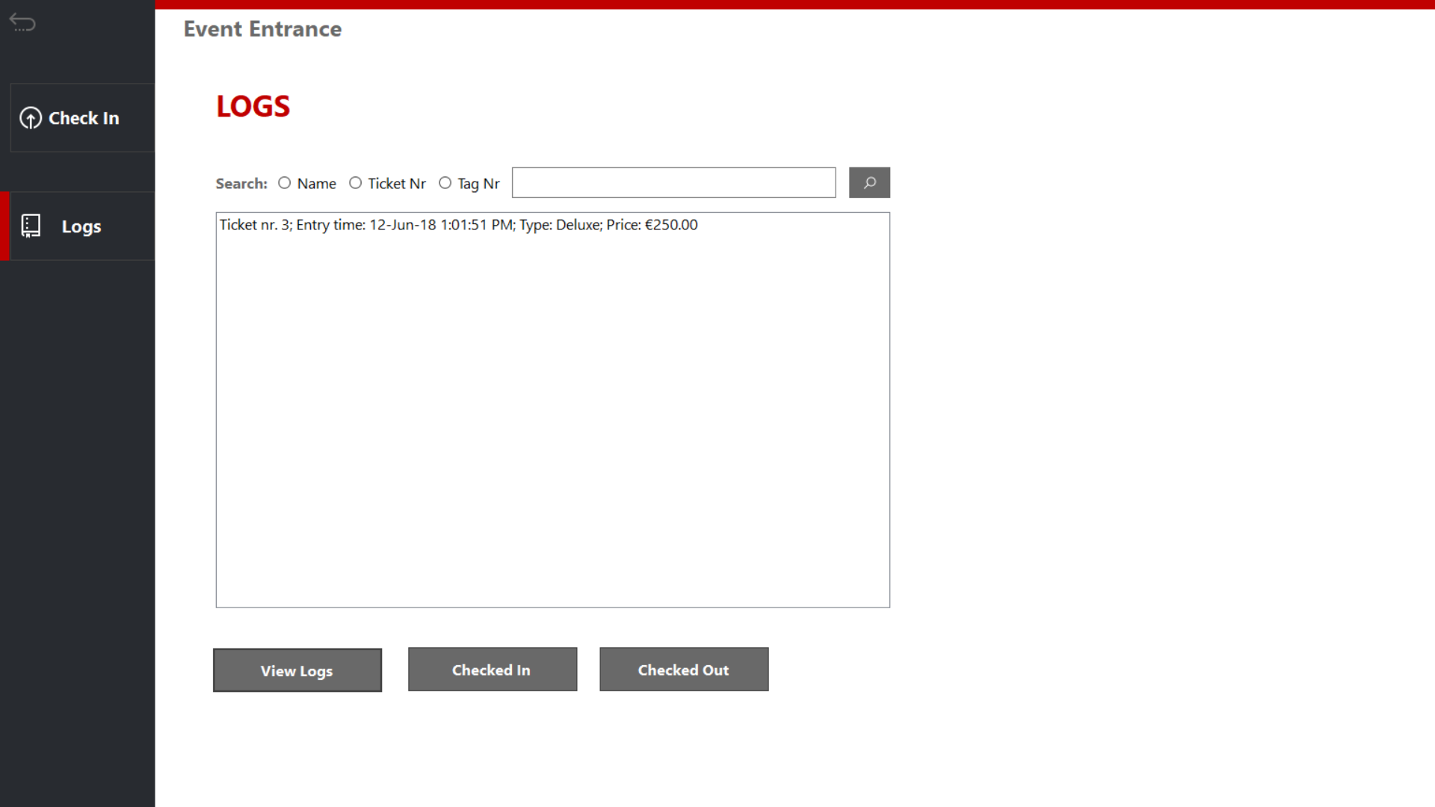

Figure 2.2 Ticket logs for event application

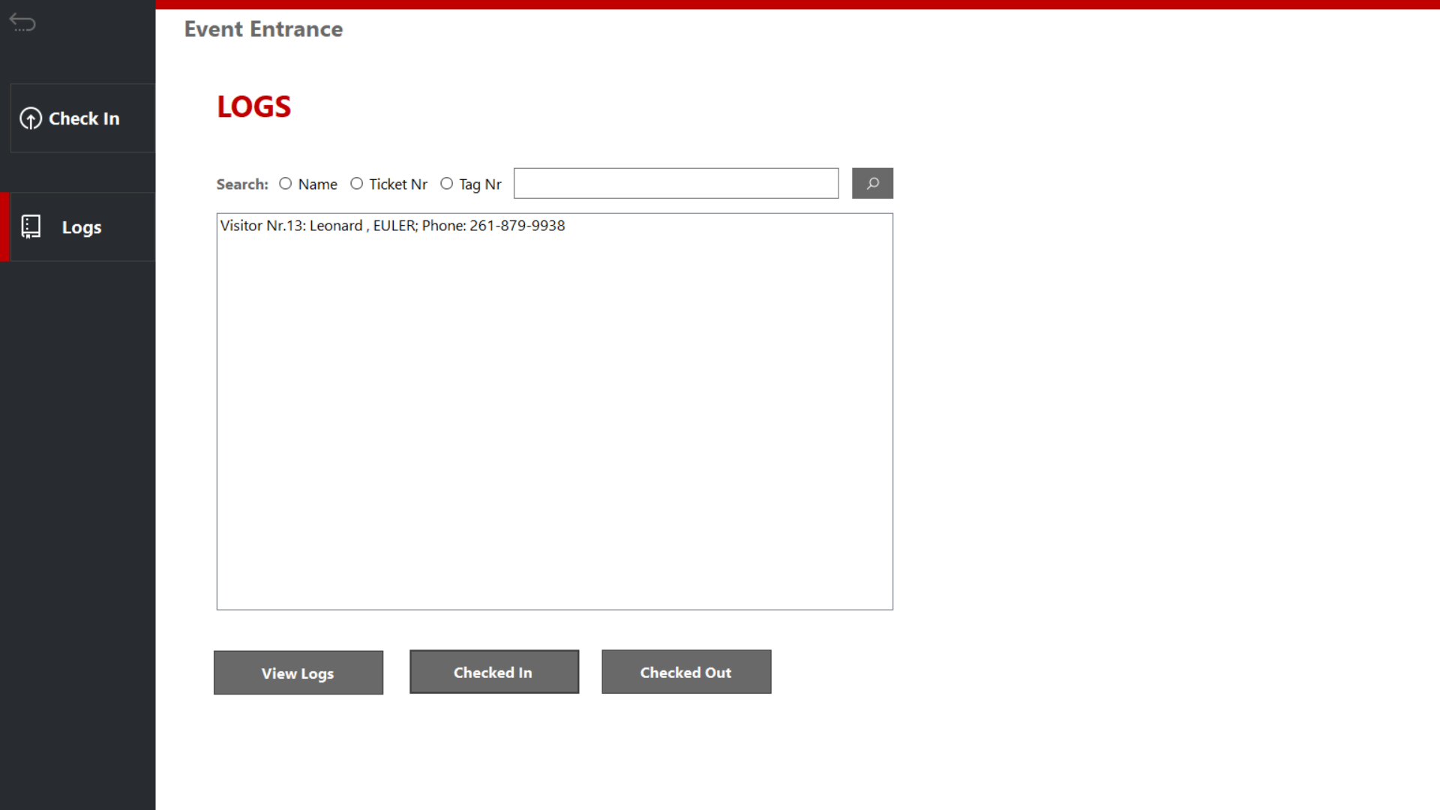

Figure 2.3 Visitor logs for entrance application

## Manager application

Manager has a home section where you can go into several sections, as can be see from the buttons in Figure 3.

1. Visitors: where you can check a variety of data related to people visiting the event (see Figure 3.1)
2. Staff: personnel related data (see Figure 3.2)
3. Camping: campsite related data (see Figure 3.3)
4. Transactions: ATM related logs and data (see Figure 3.4)
5. Logout brings you back to the login form.

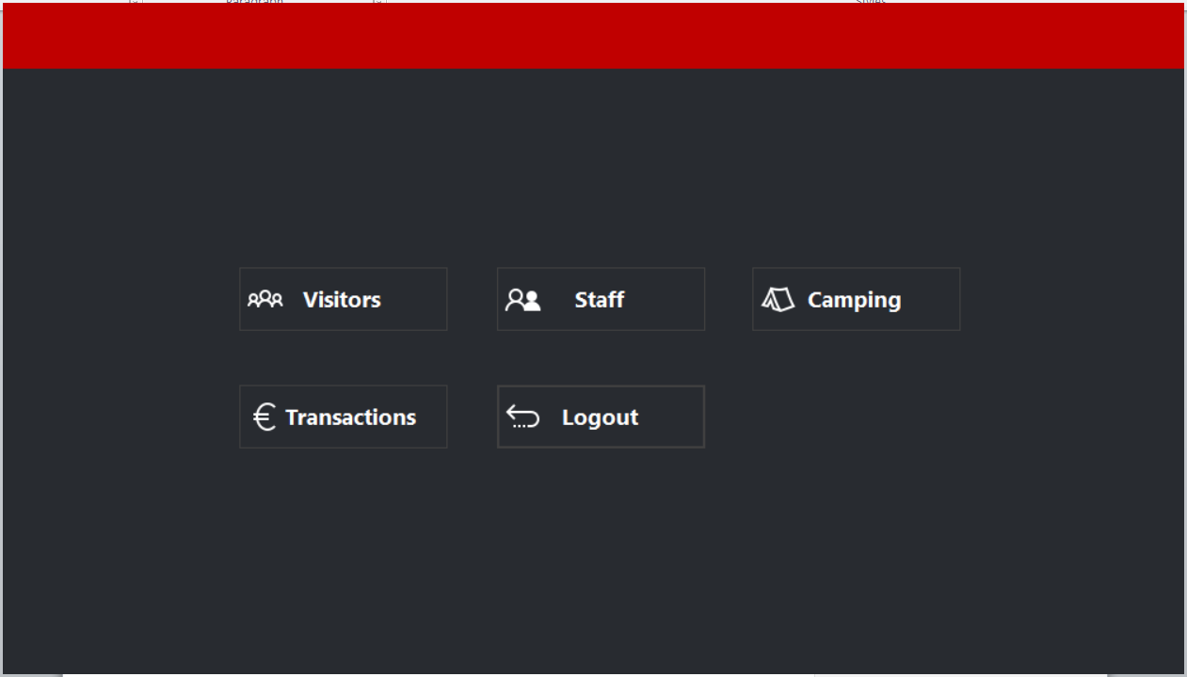

Figure . Home form

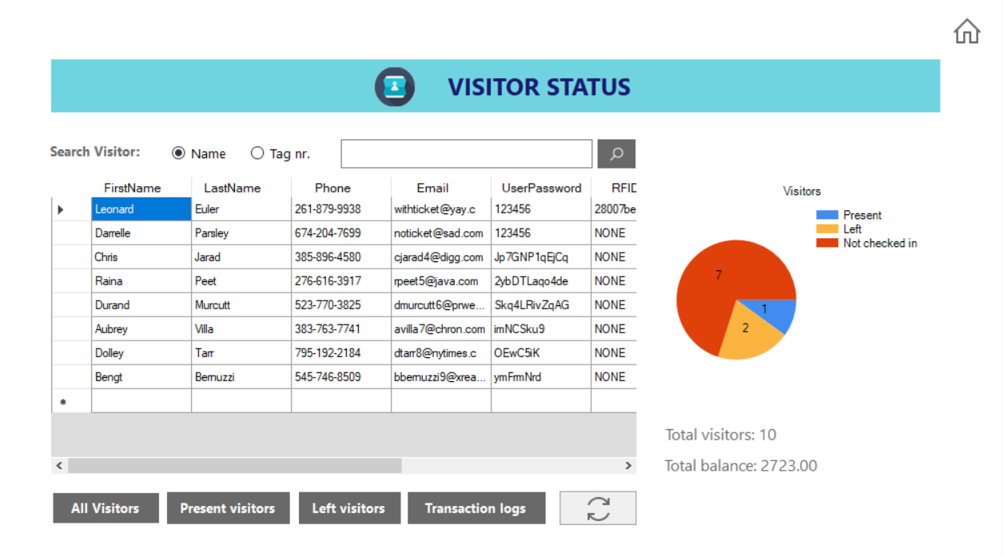

Figure 3.1 Visitor data

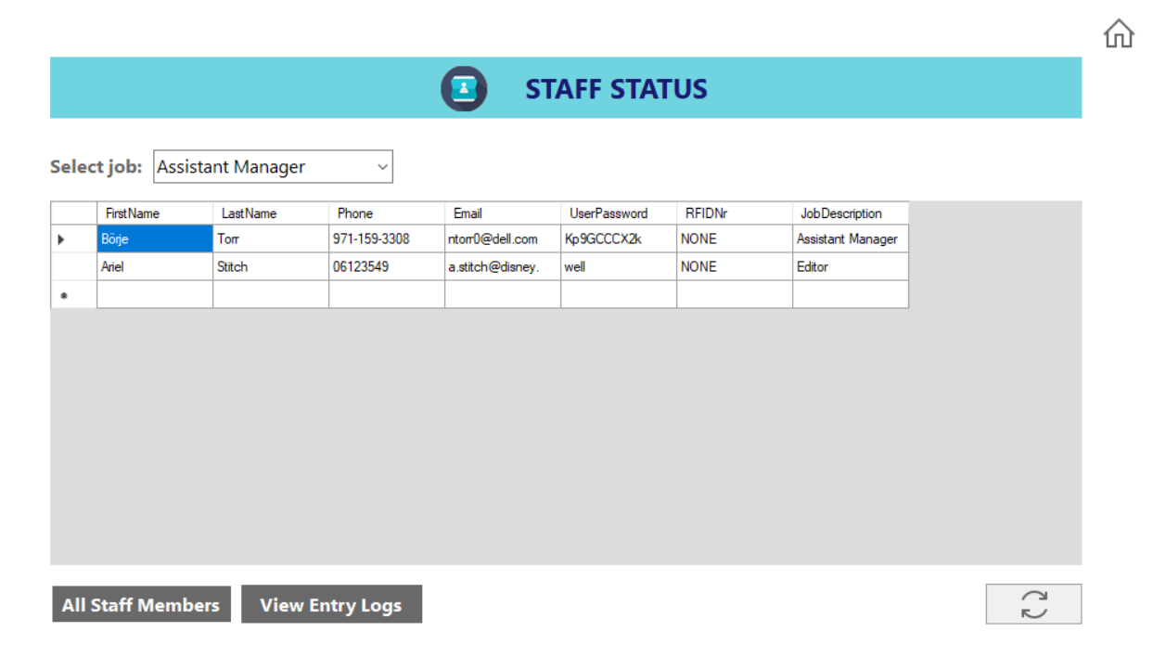

Figure 3.2 Staff data

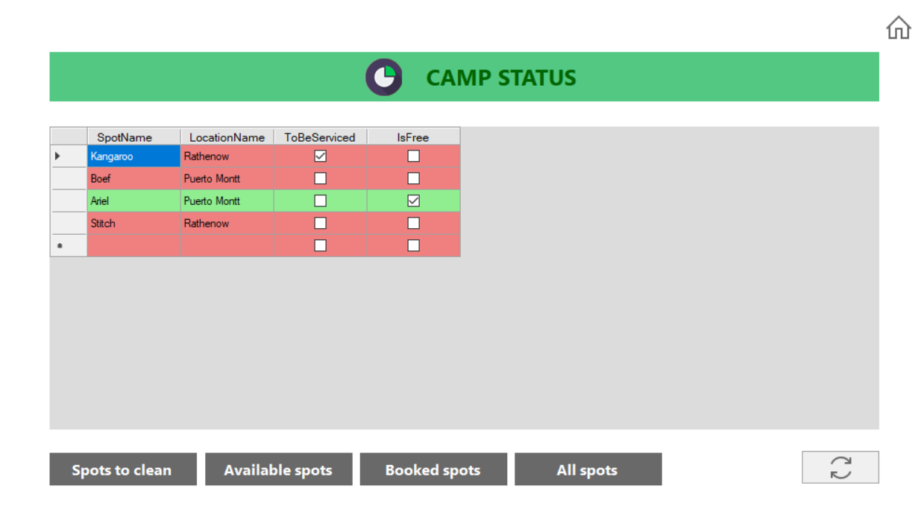

Figure 3.3 Camp data

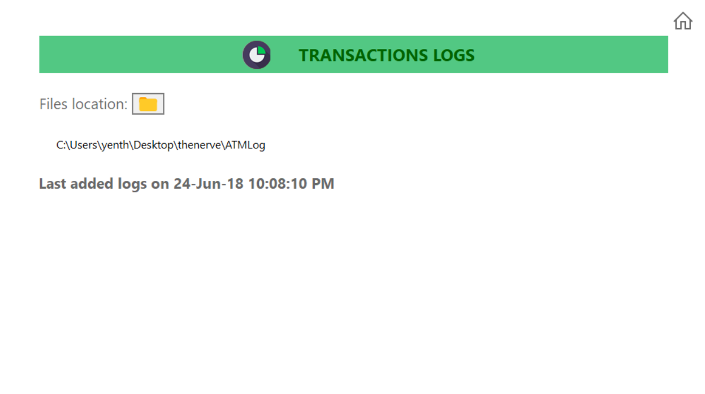

Figure 3.4 Transactions logs

## Rental Application

The rental application has three sections:

1. Loaning: The section used for scanning items that visitors might want to borrow (see Figure 4.1)
2. Returning: Section used for scanning items that visitors are returning (see Figure 4.2)
3. Logs: The section used to see and/or search relevant data (see Figure 4.2)

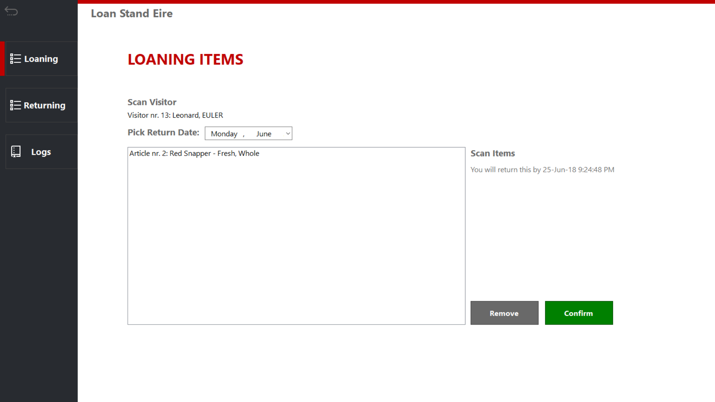

Figure .1 Loan section

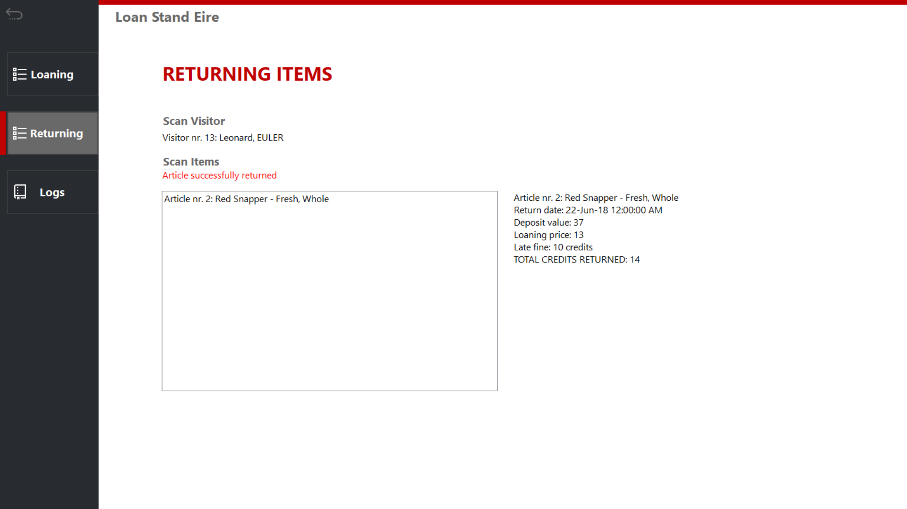

Figure 4.2 Returning items

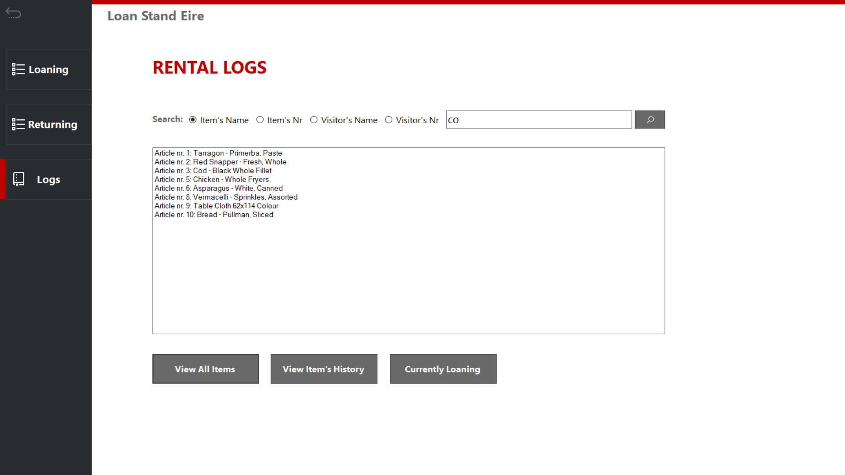

Figure 4.3 Rental logs

## Entrance application

The Store application has two sections:

1. Order: The section used for ordering food or drink items (see Figure 5.1)
2. Logs: The section used to see and/or search relevant data, like stock (see Figure 5.2)

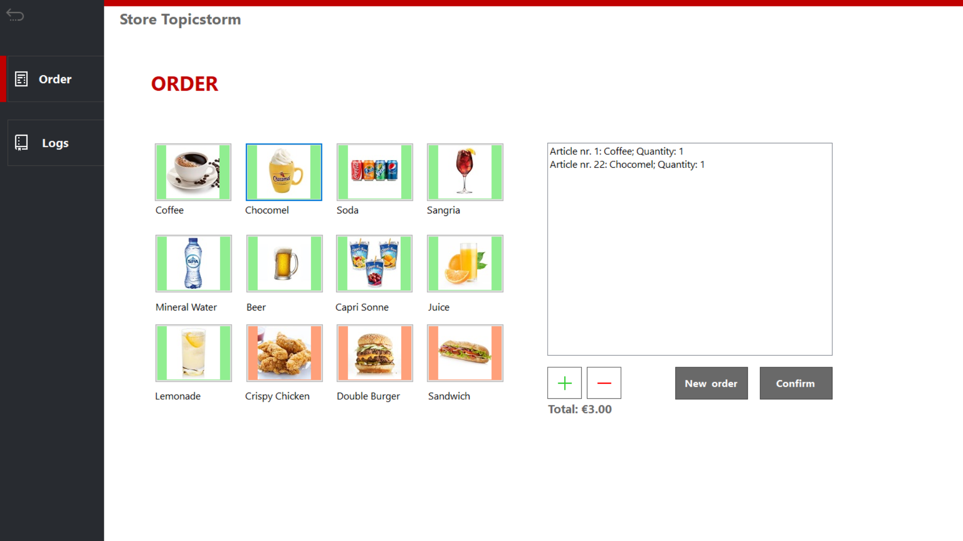

Figure .1 Taking an order

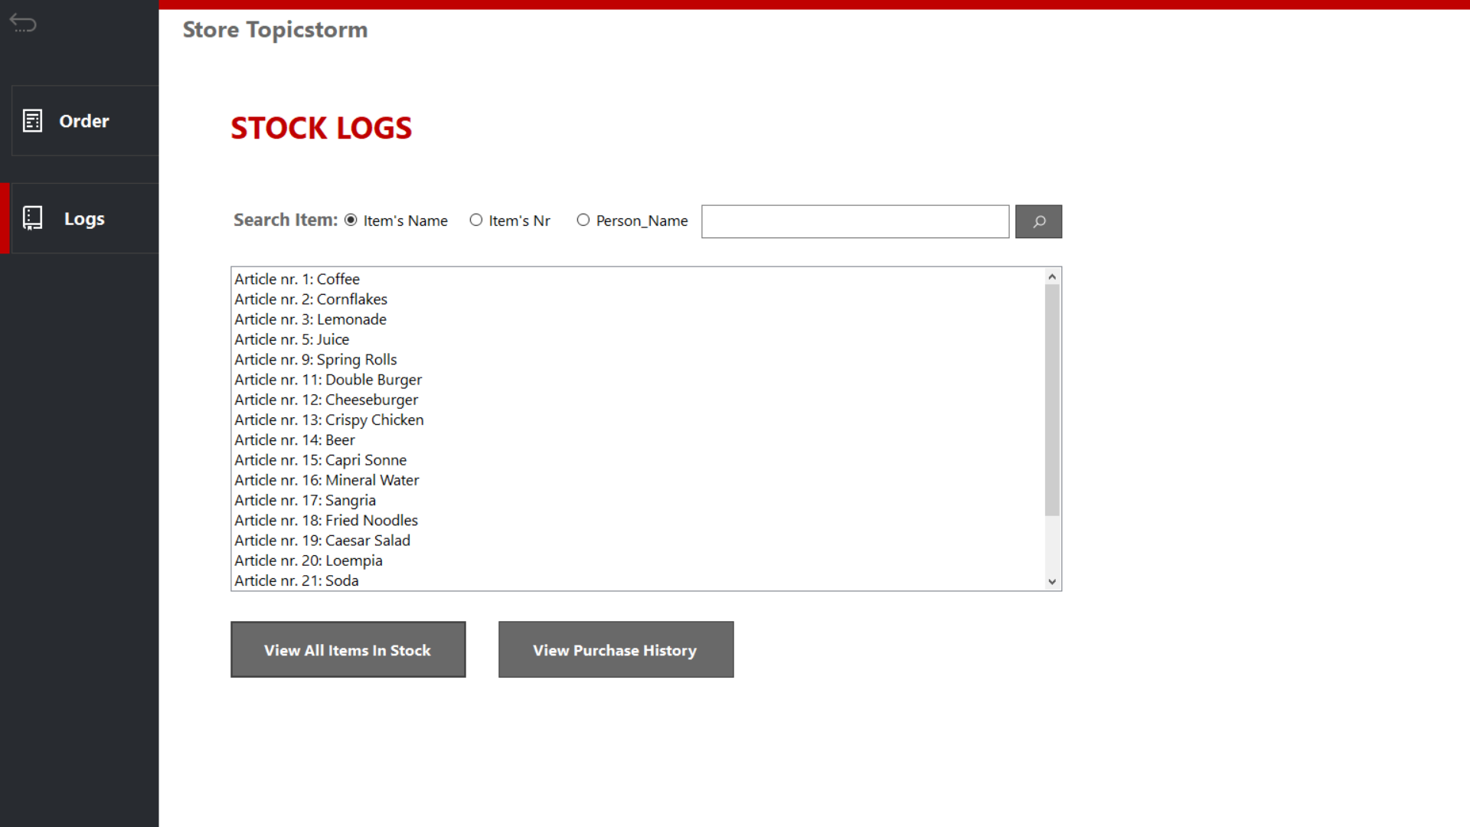

Figure 5.2 Stock logs

# Wireframes

## Homepage:

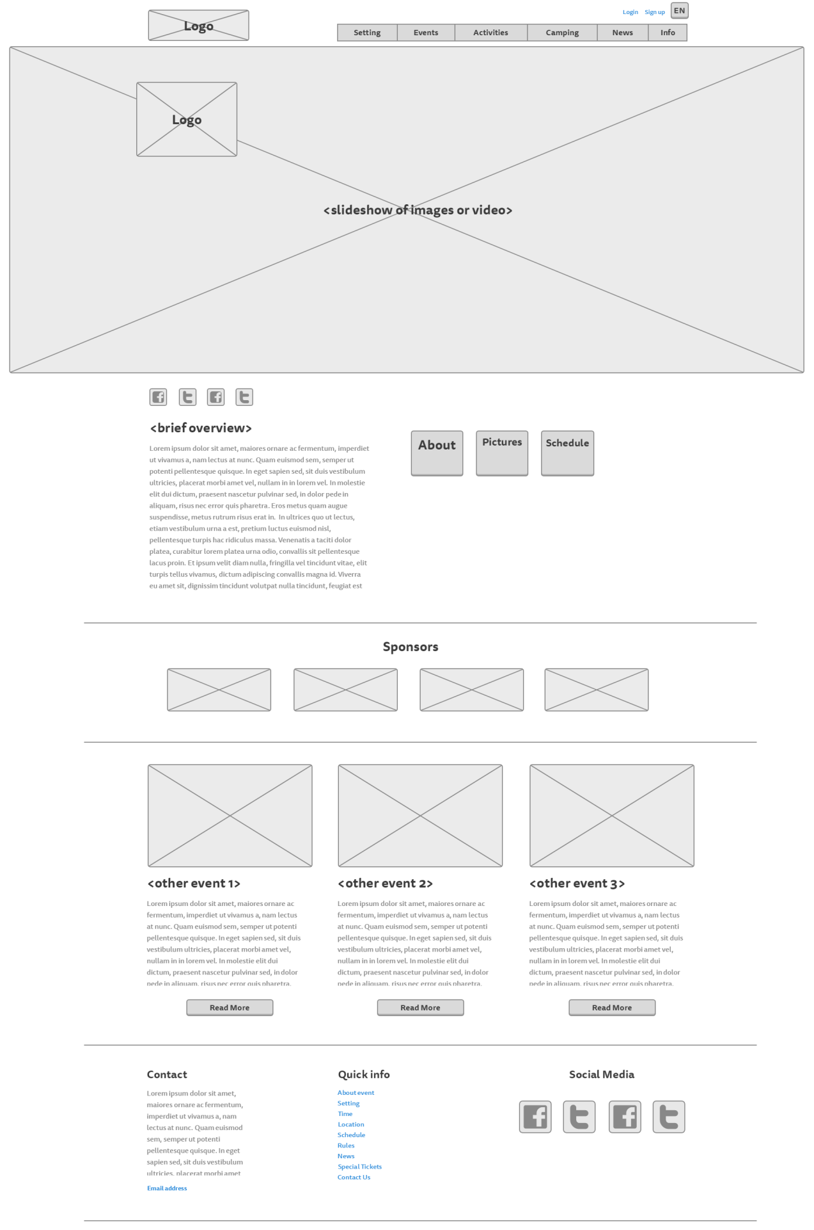

## Story So Far page:

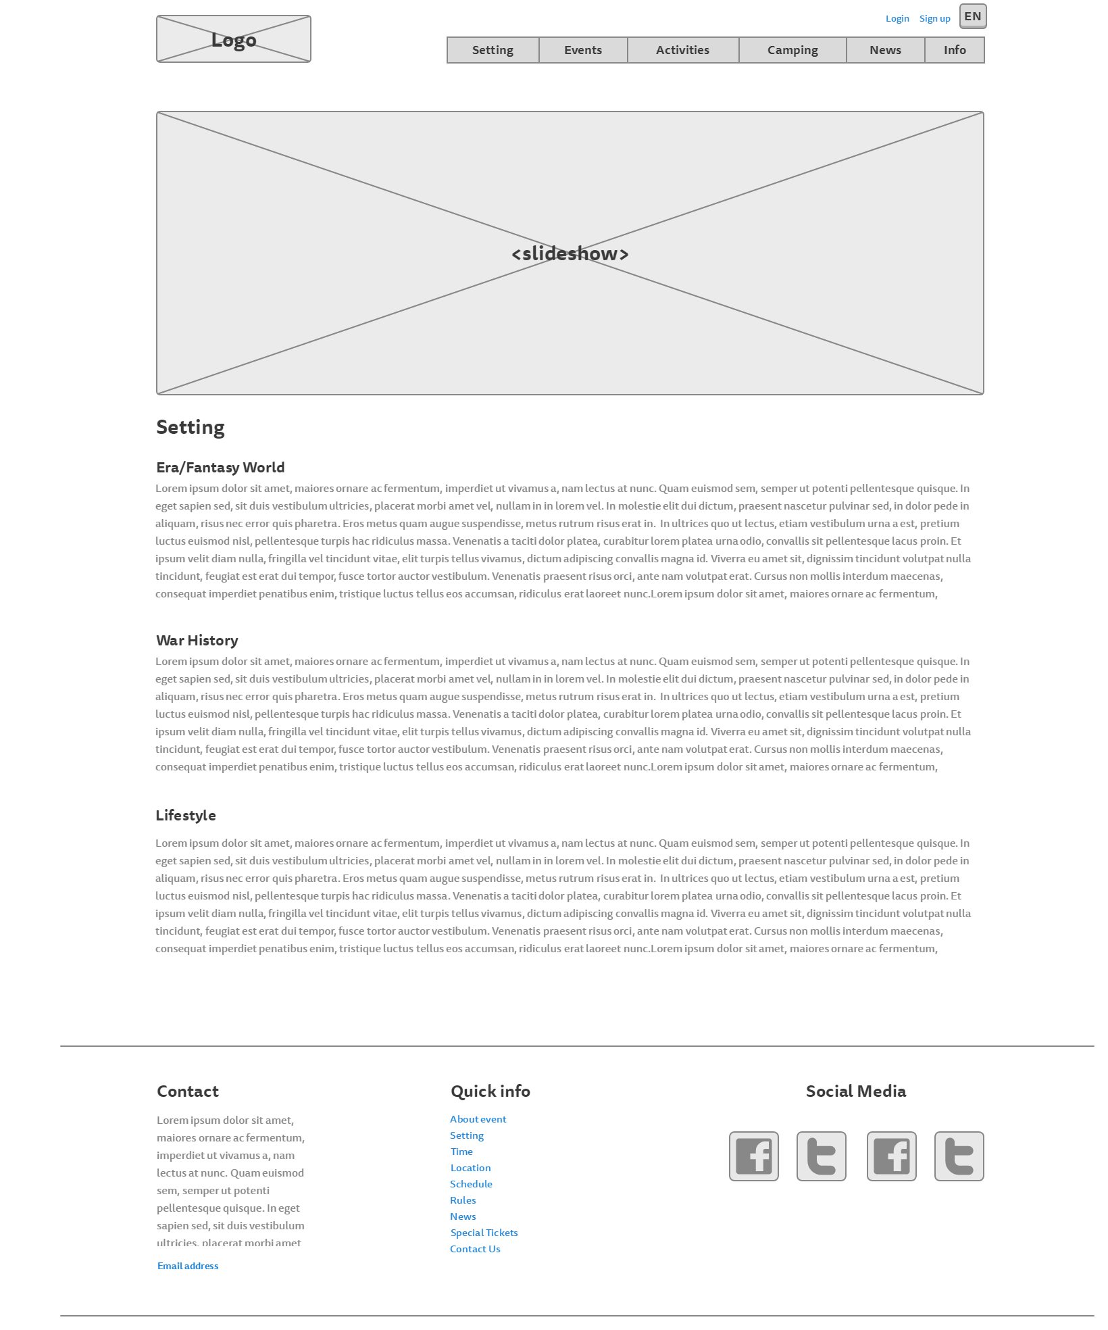

## Rules page:

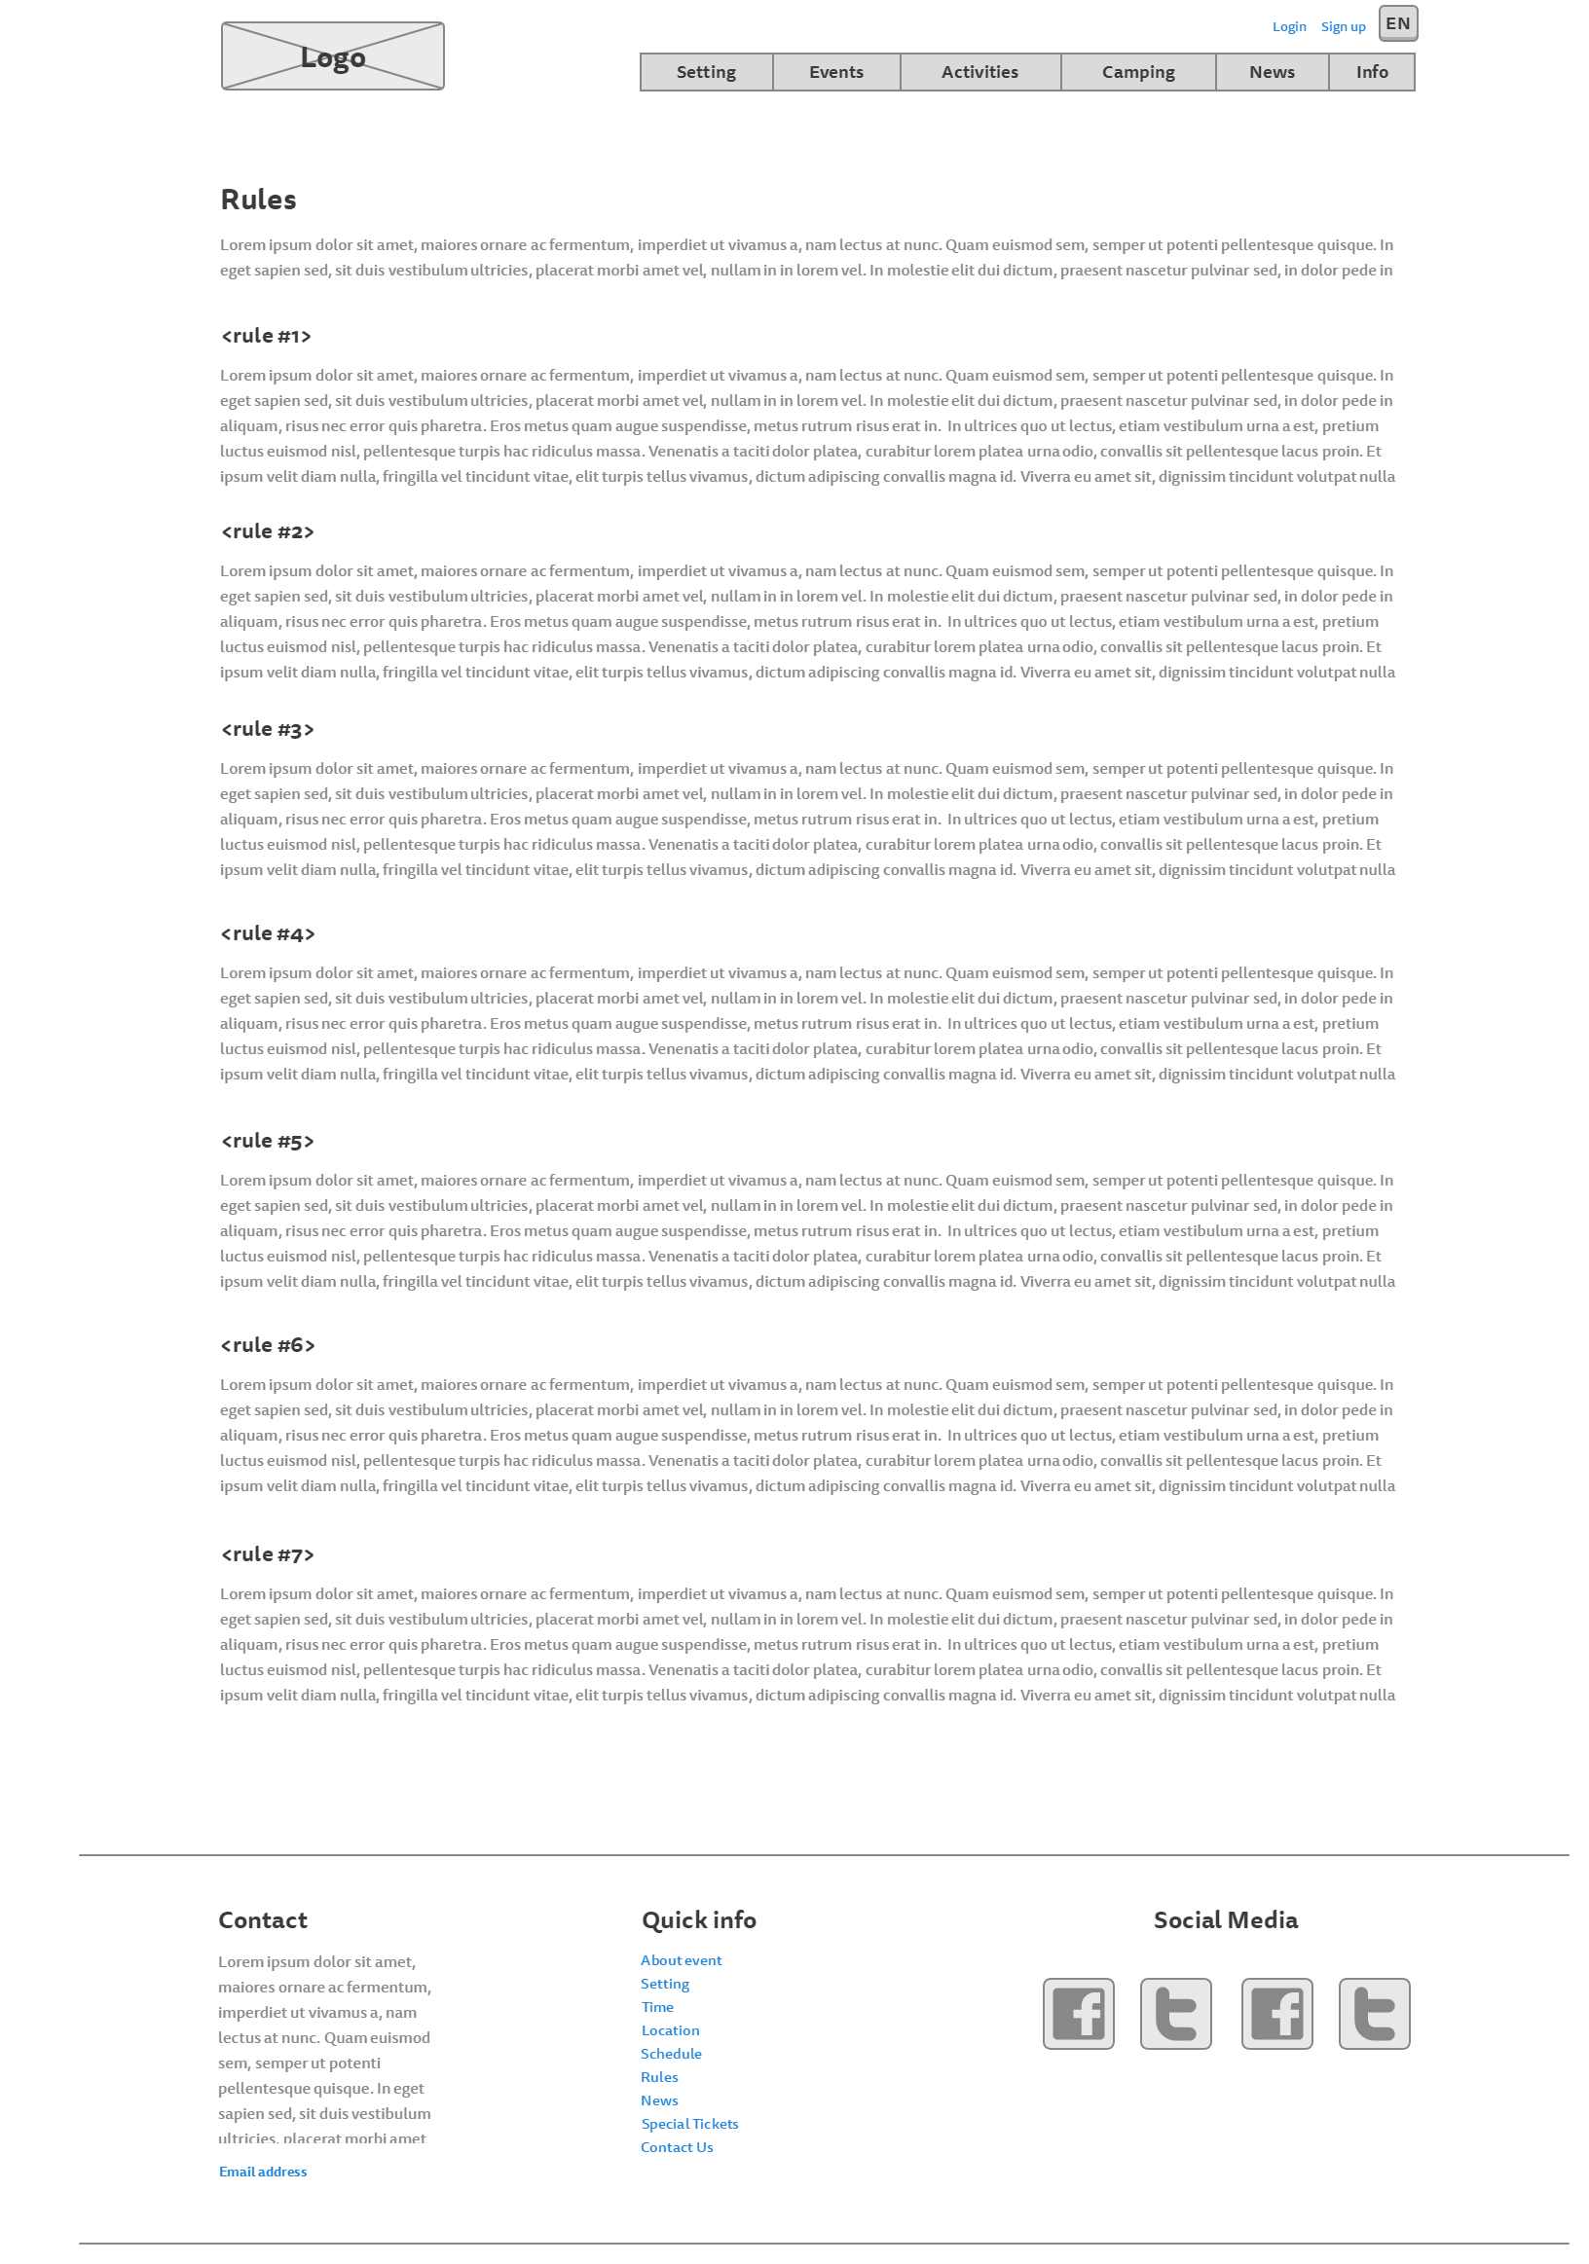

## Events page

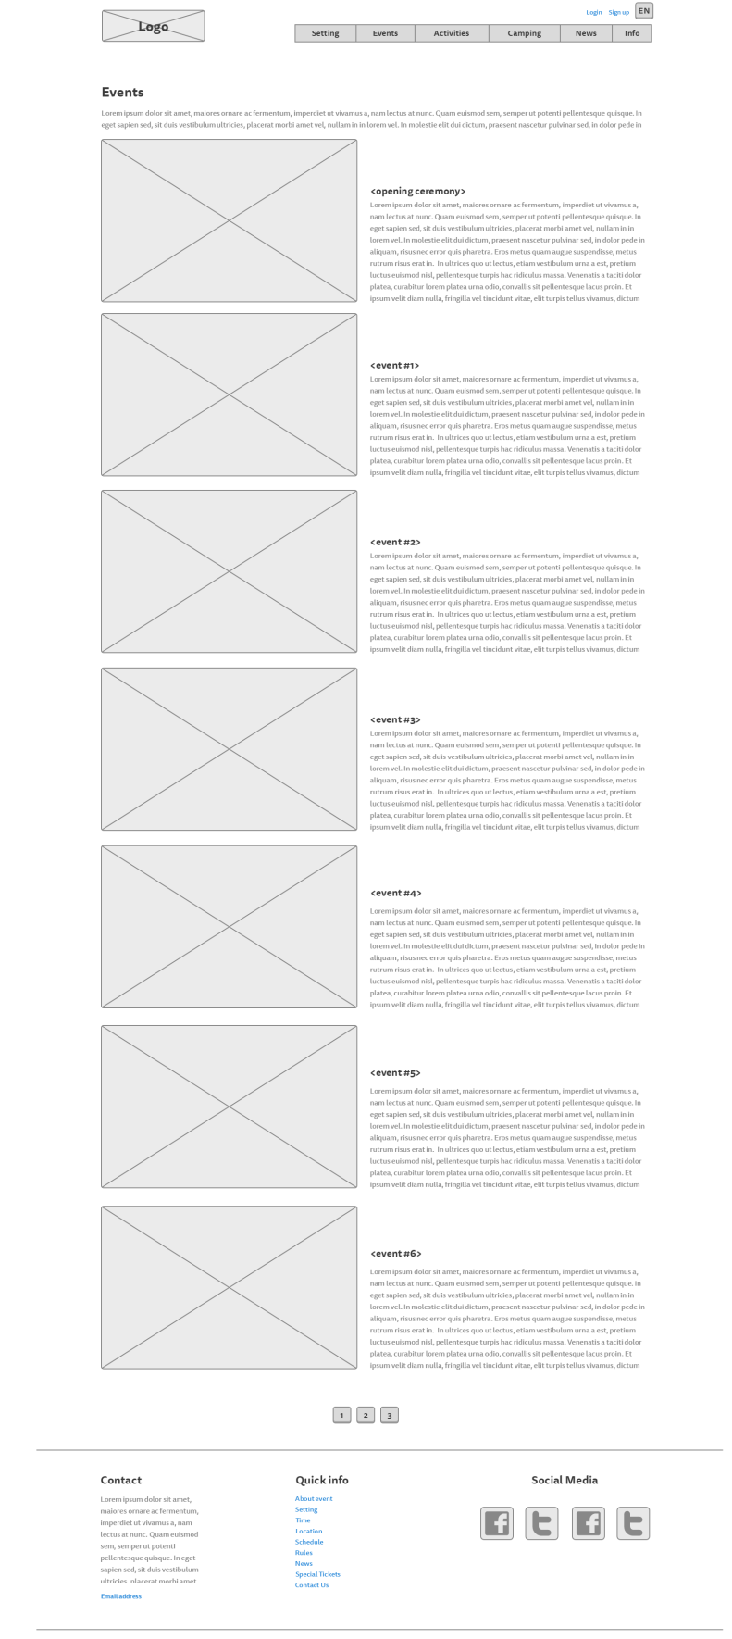

## Activities page:

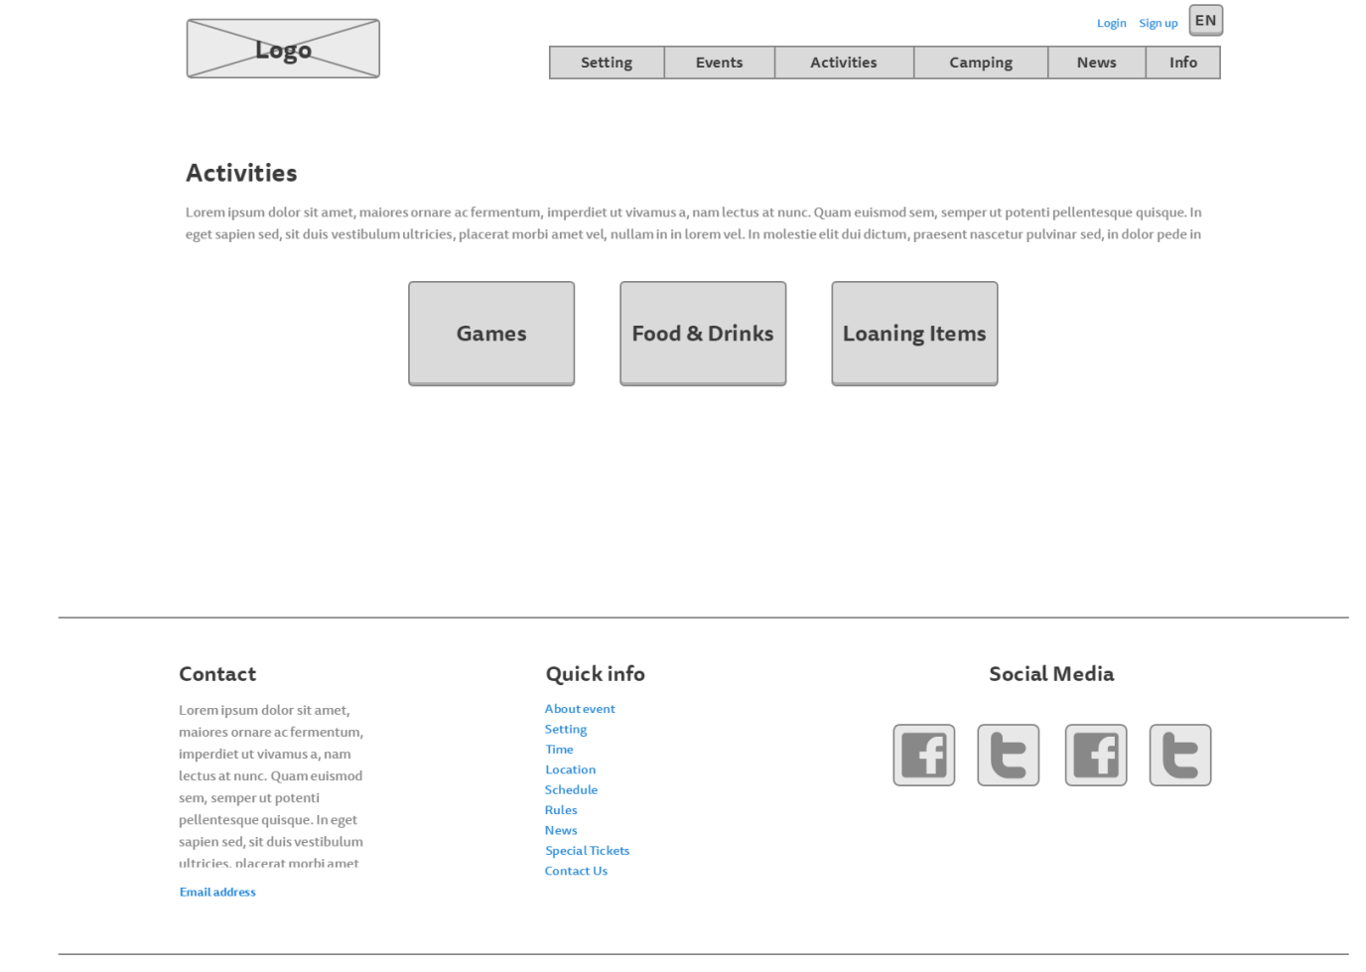

## Food, drinks and loaning items page

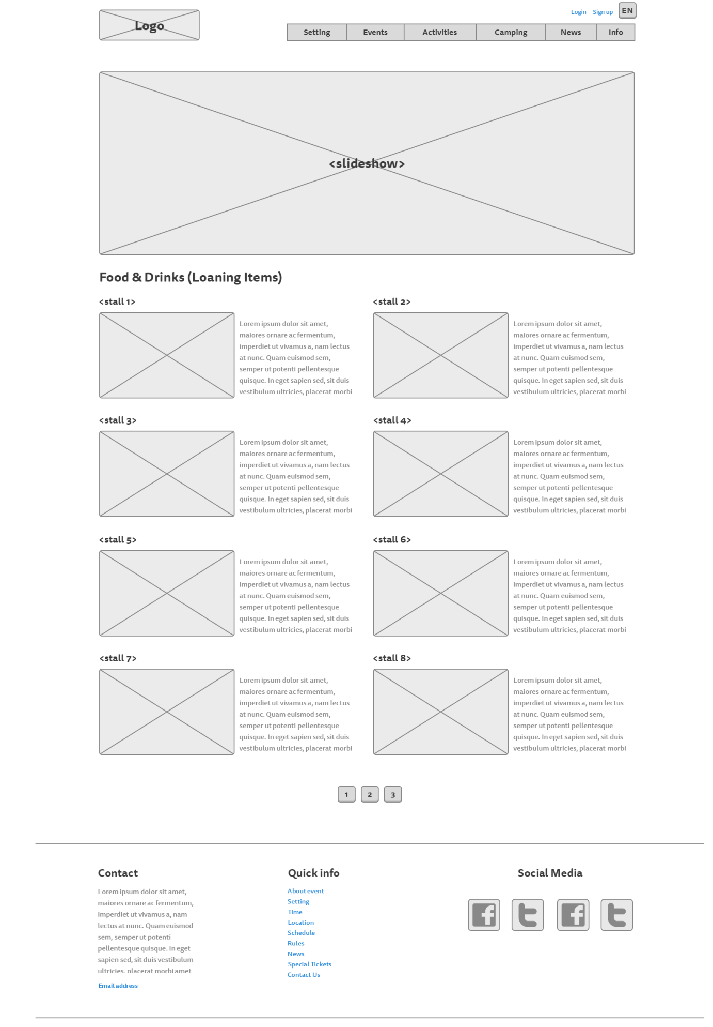

## Games page:

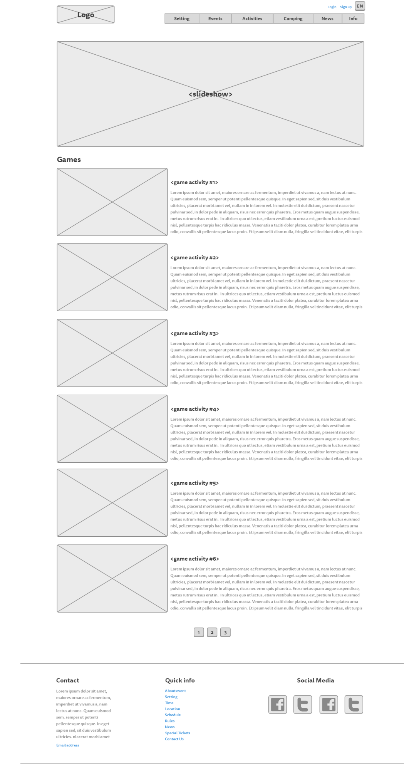

## Camping page:

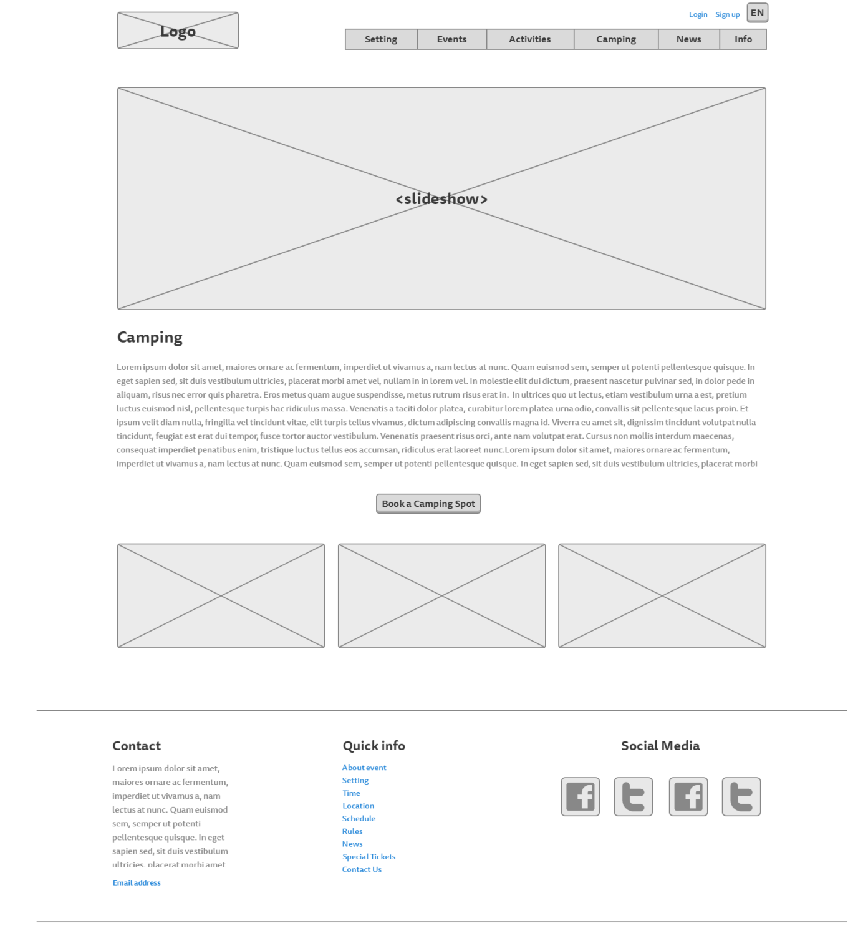

## News page:

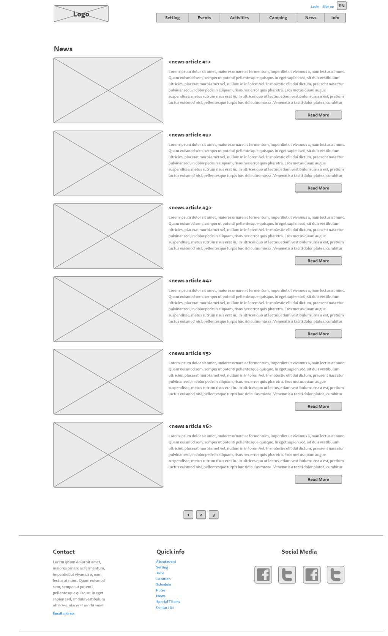

## News – read more:

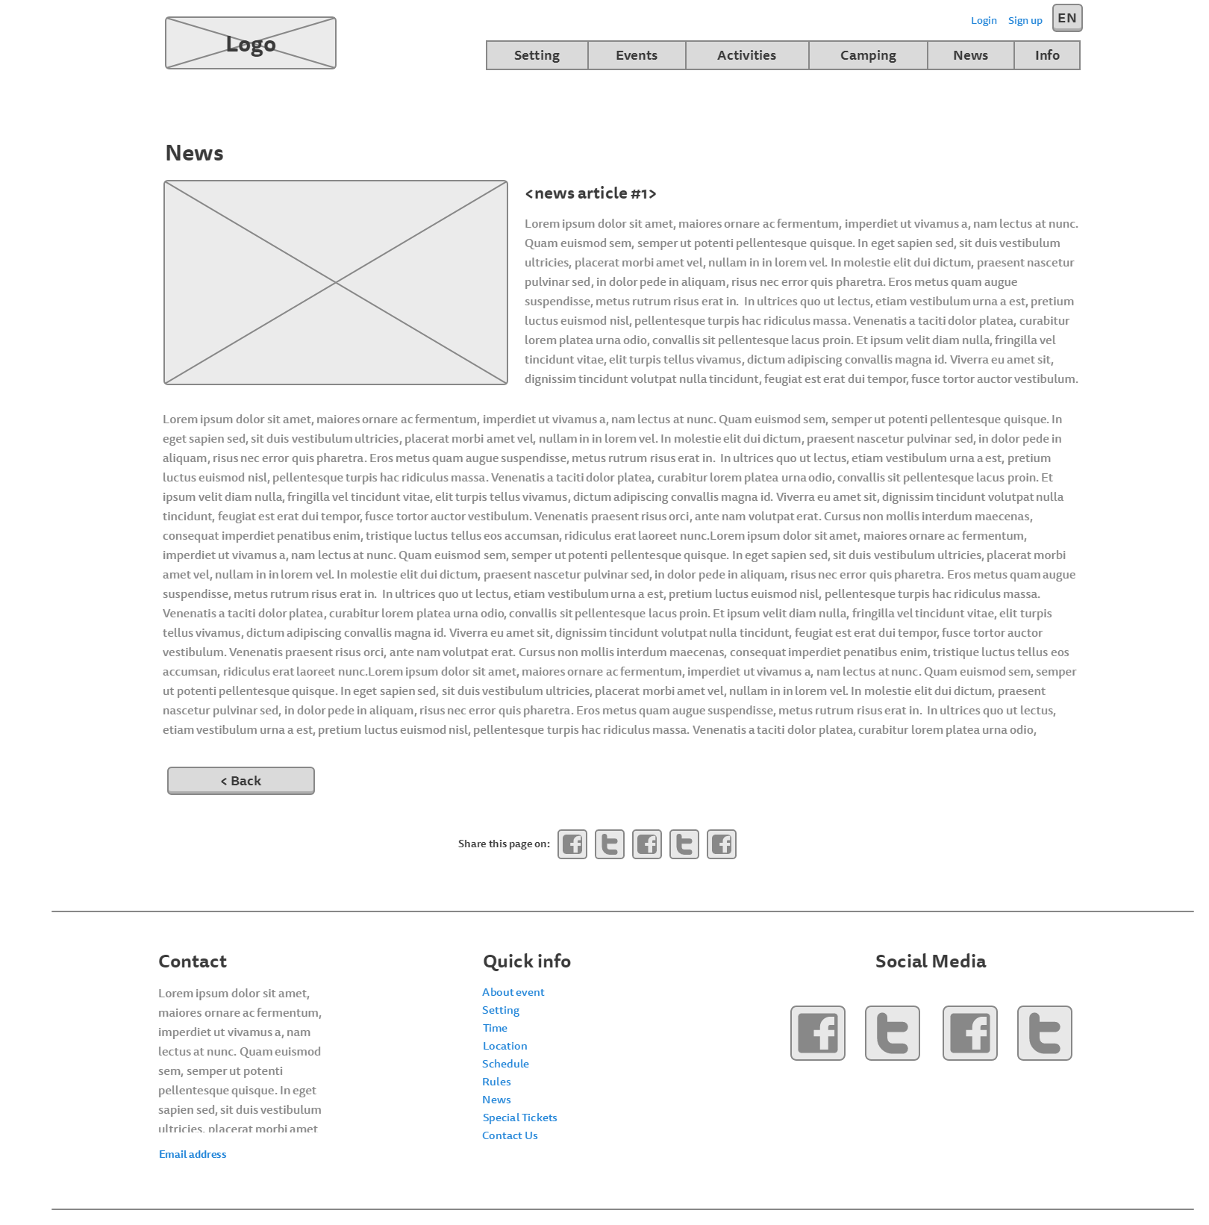

## About page:11-Info

## Login page:

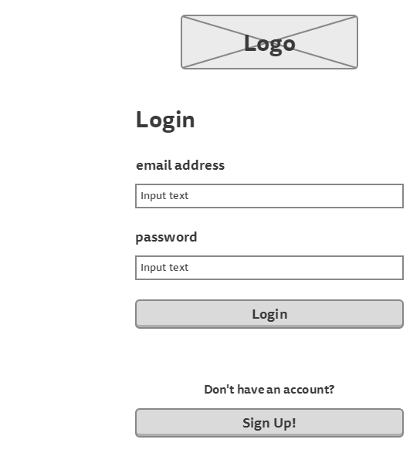

## Sign up page:

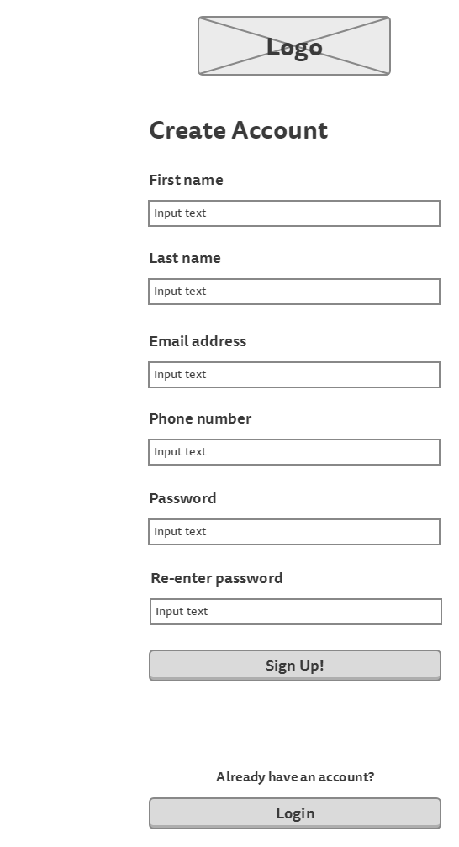

## Participant’s information page

(to show tickets information)

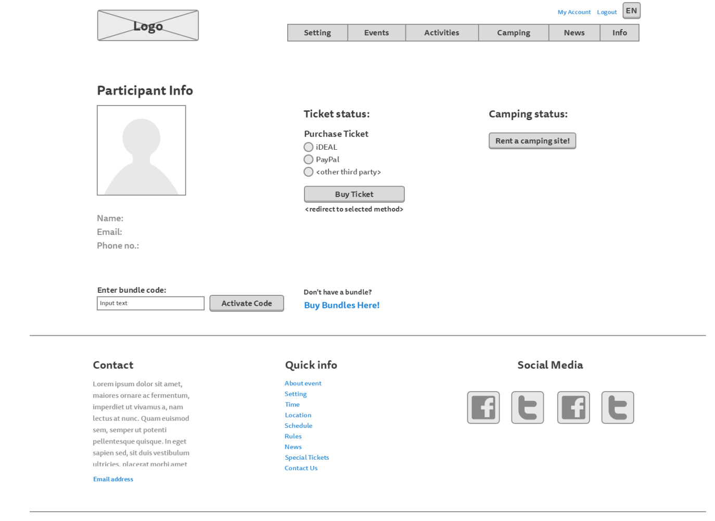

## Participant’s information page

(to show camping information)

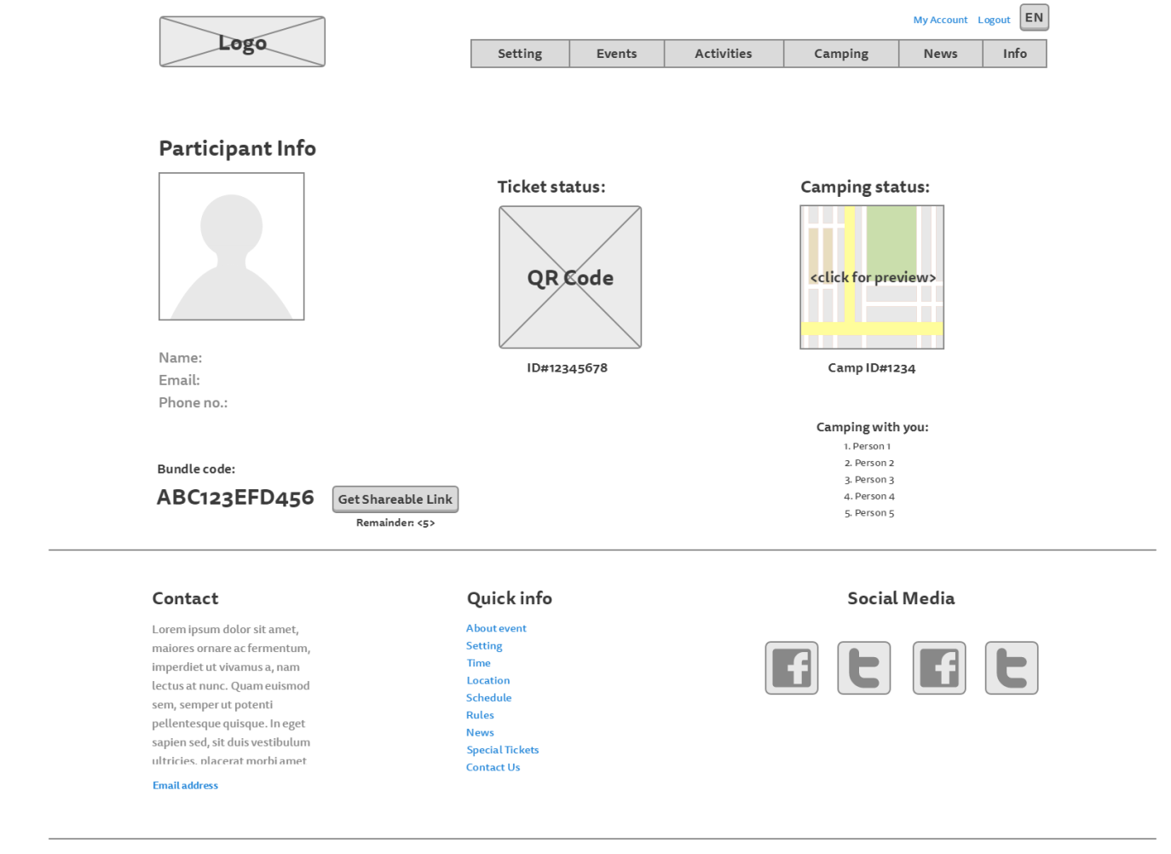

## Camping registration page:

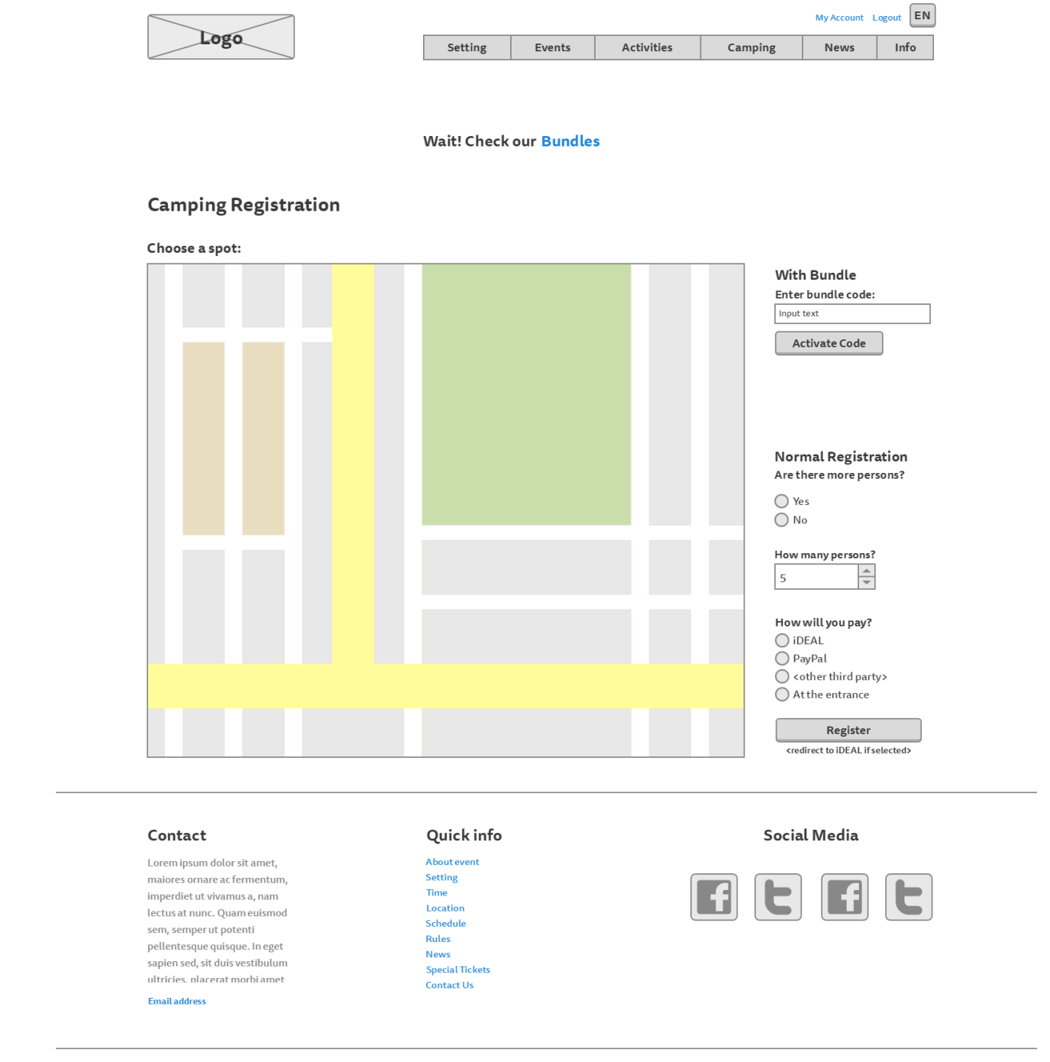

## Bundles page:

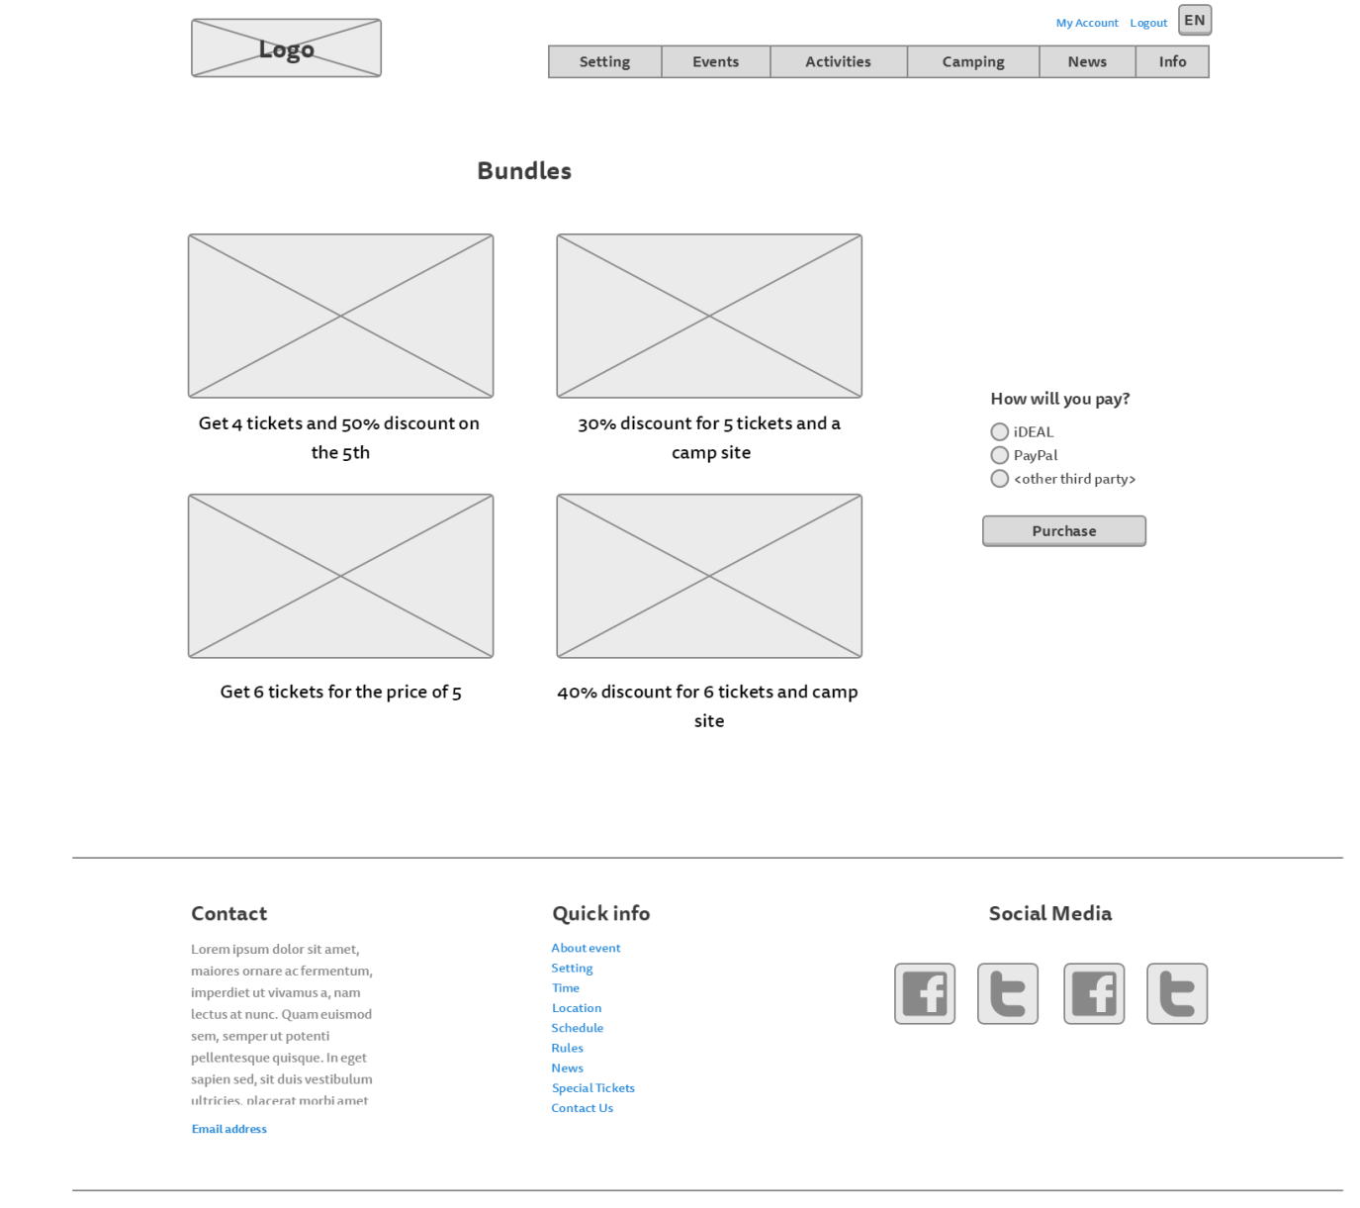

# Visual Design

## Homepage:

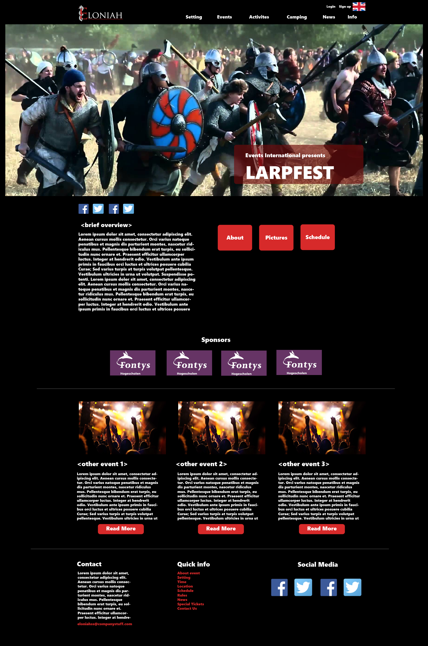

## Story So Far:

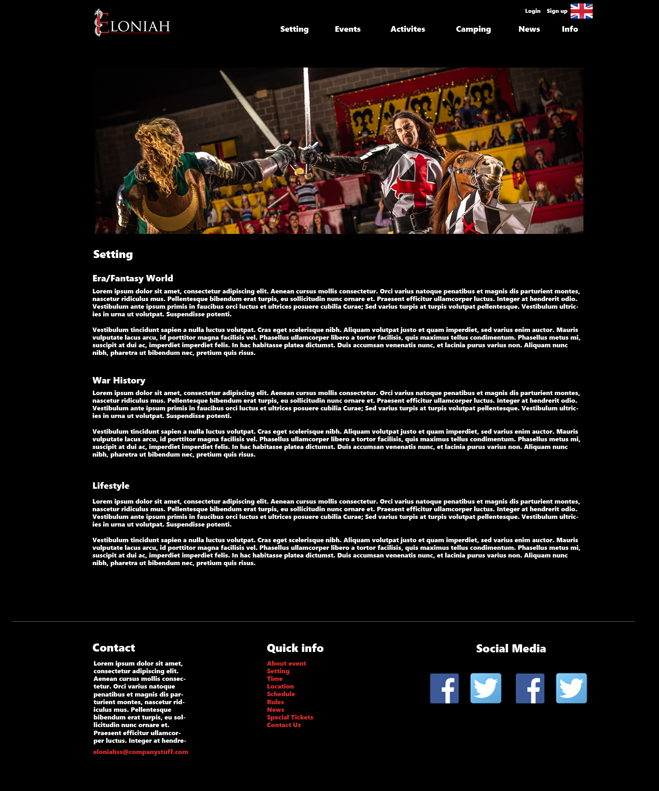

## Rules page:

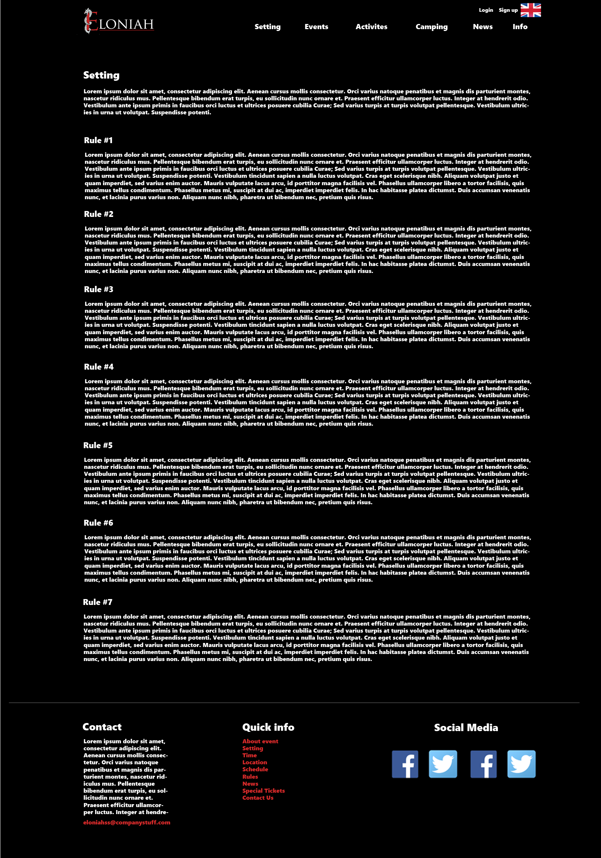

## Events page

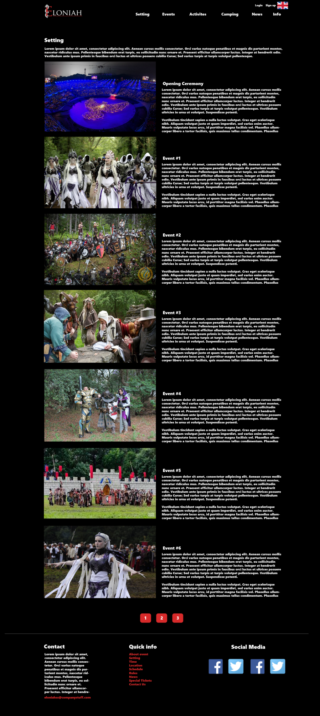

## Activities page:

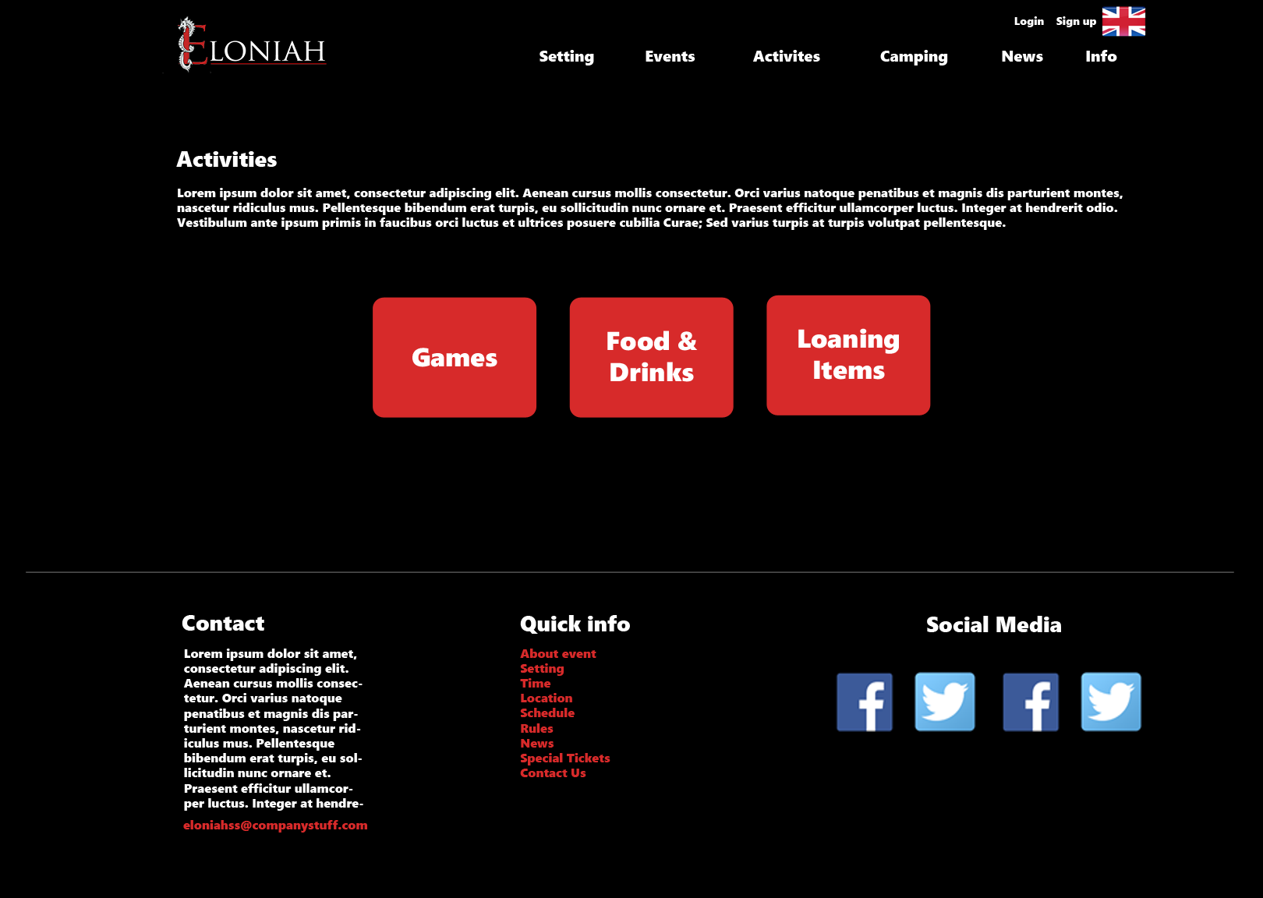

## Food, drinks and loaning items page

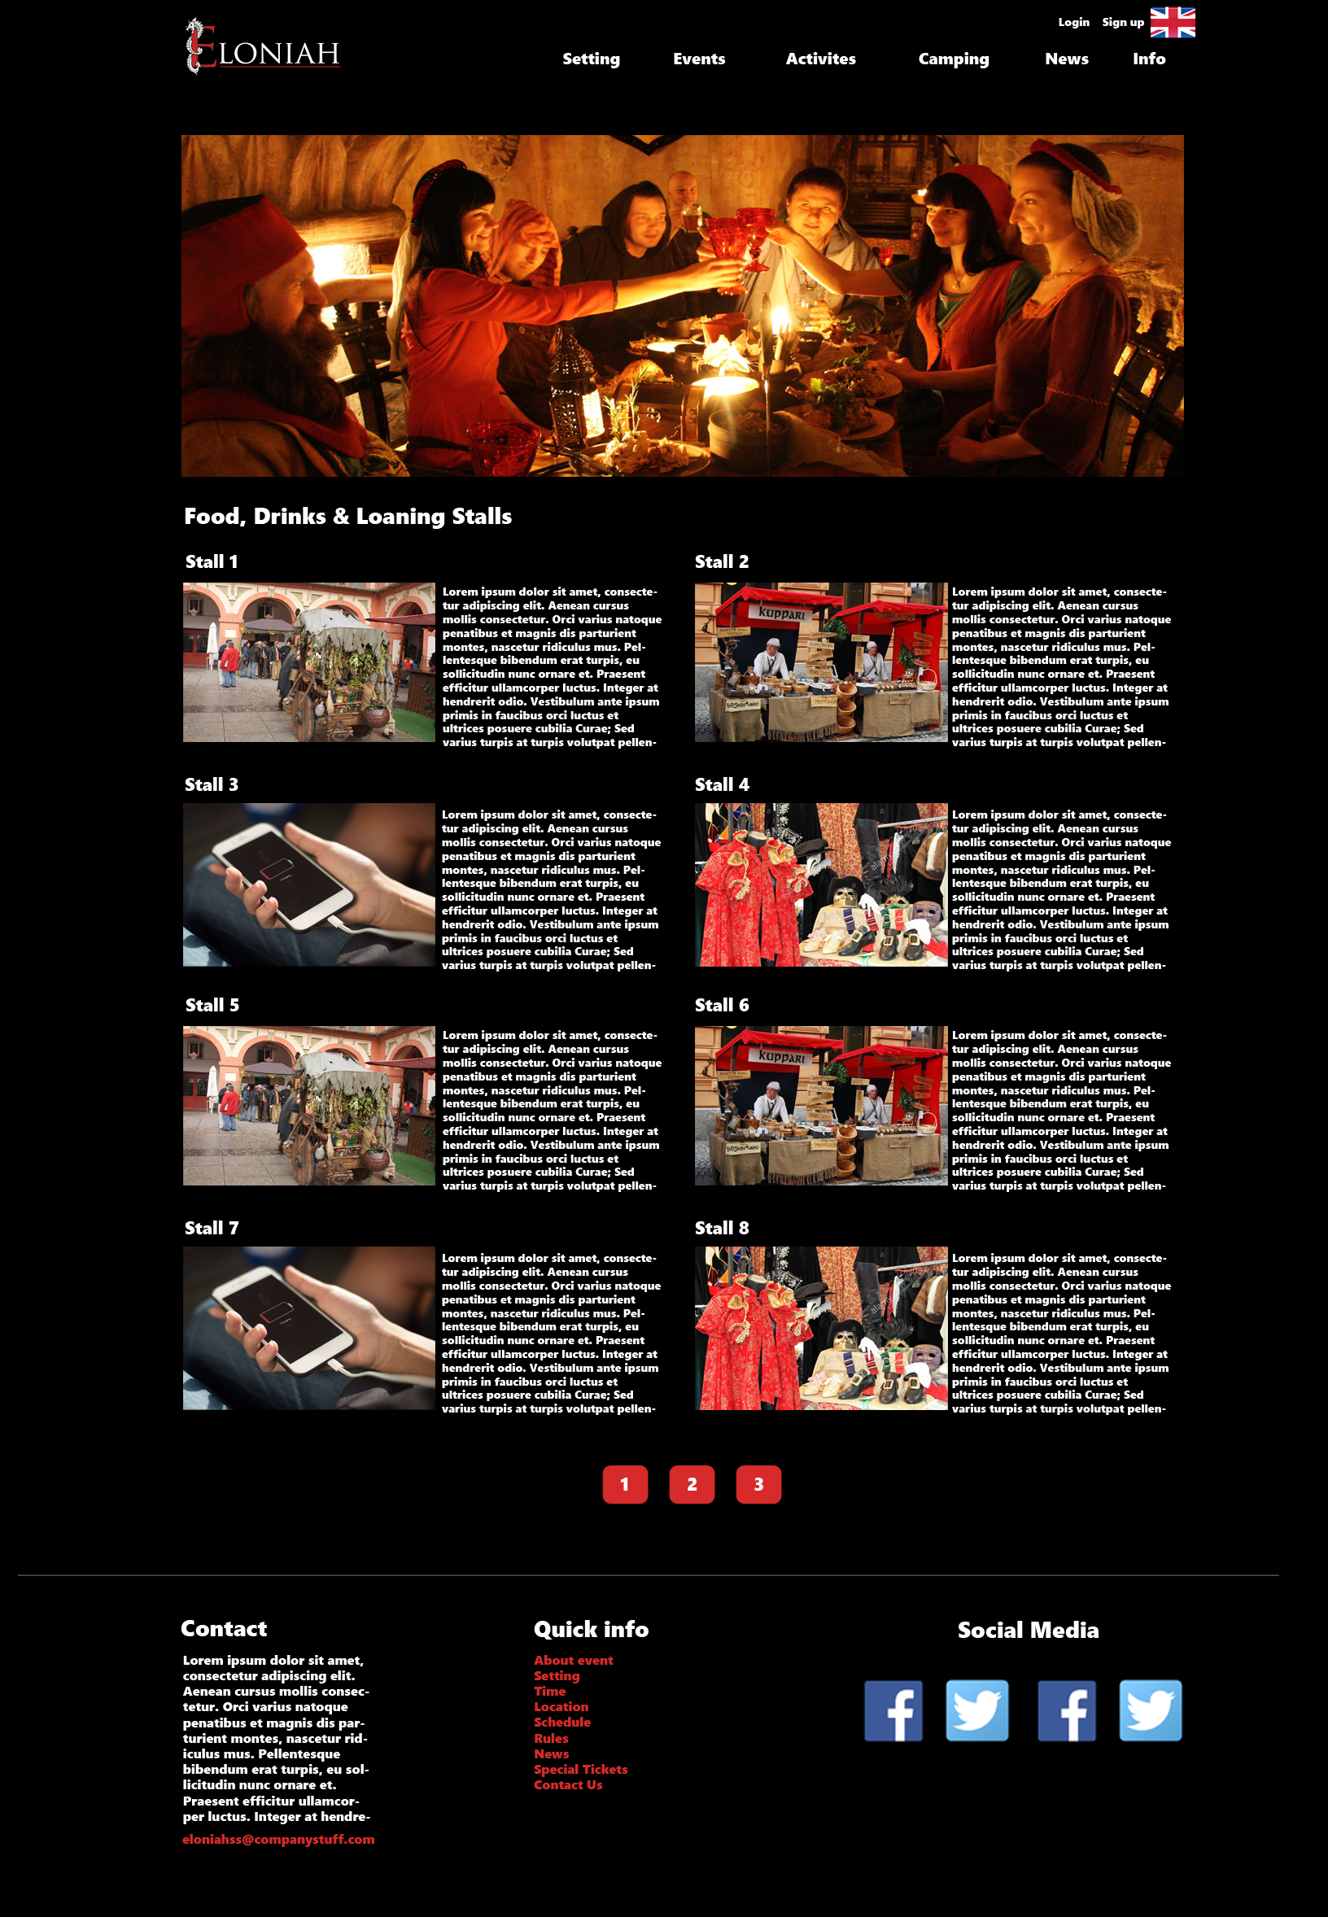

## Games page:

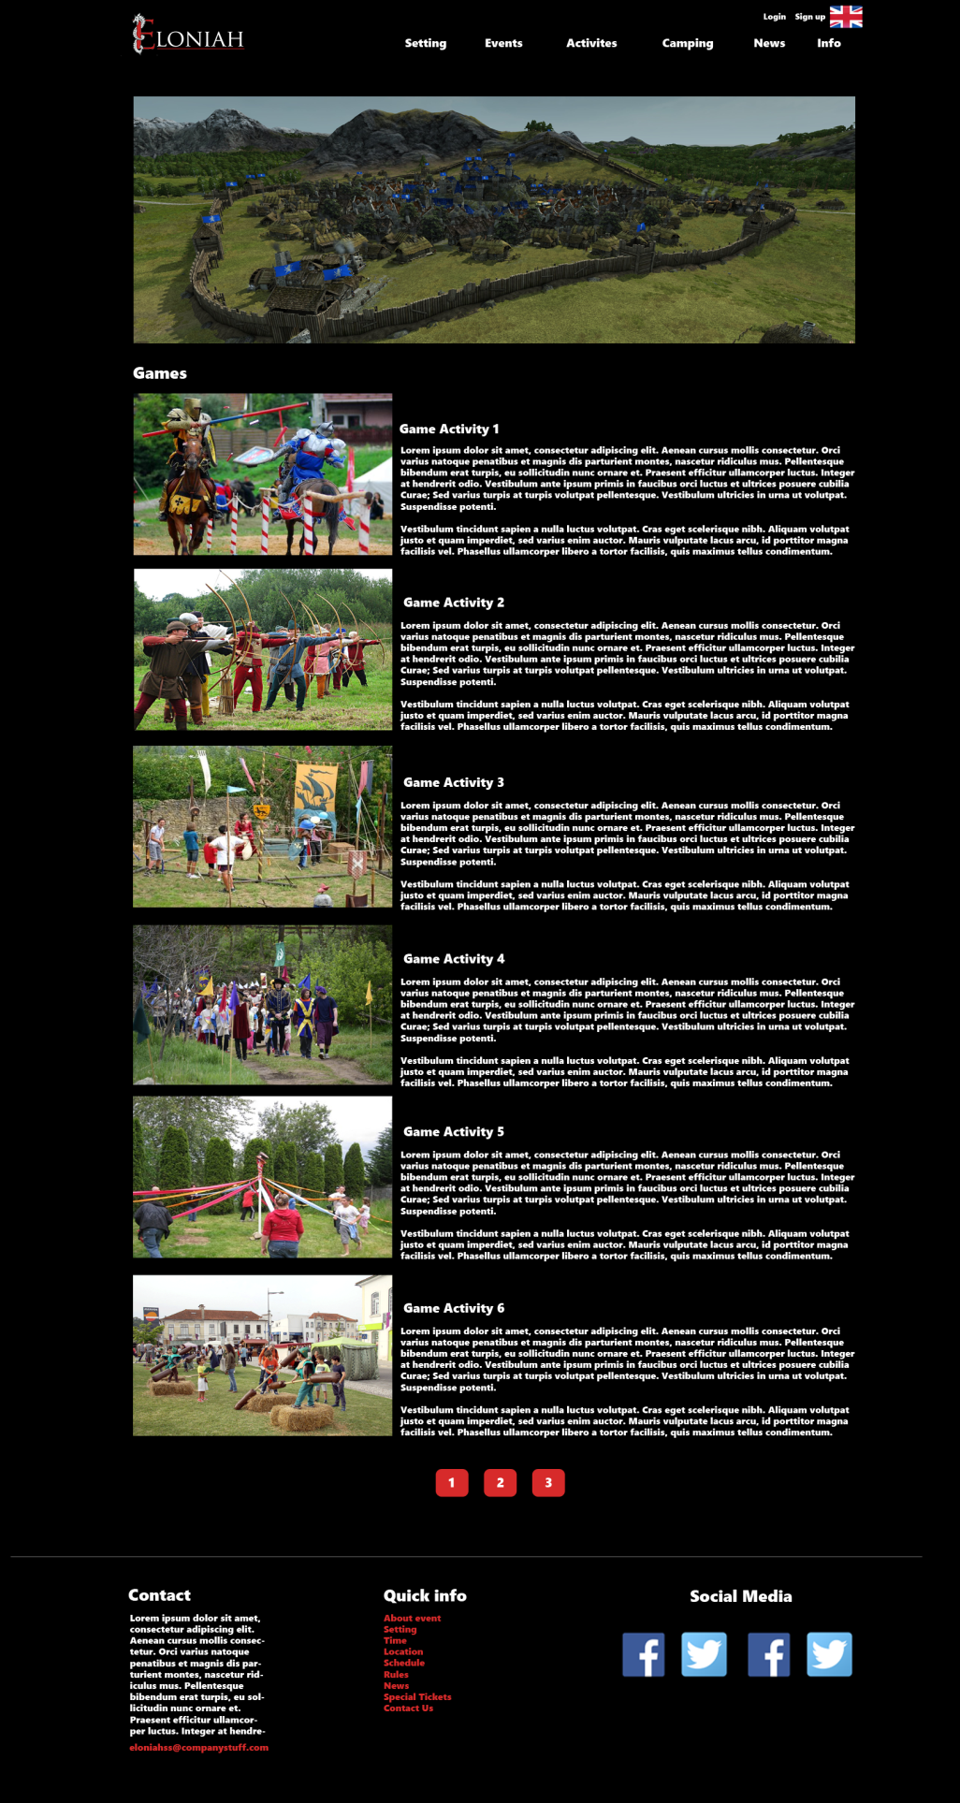

## Camping page:

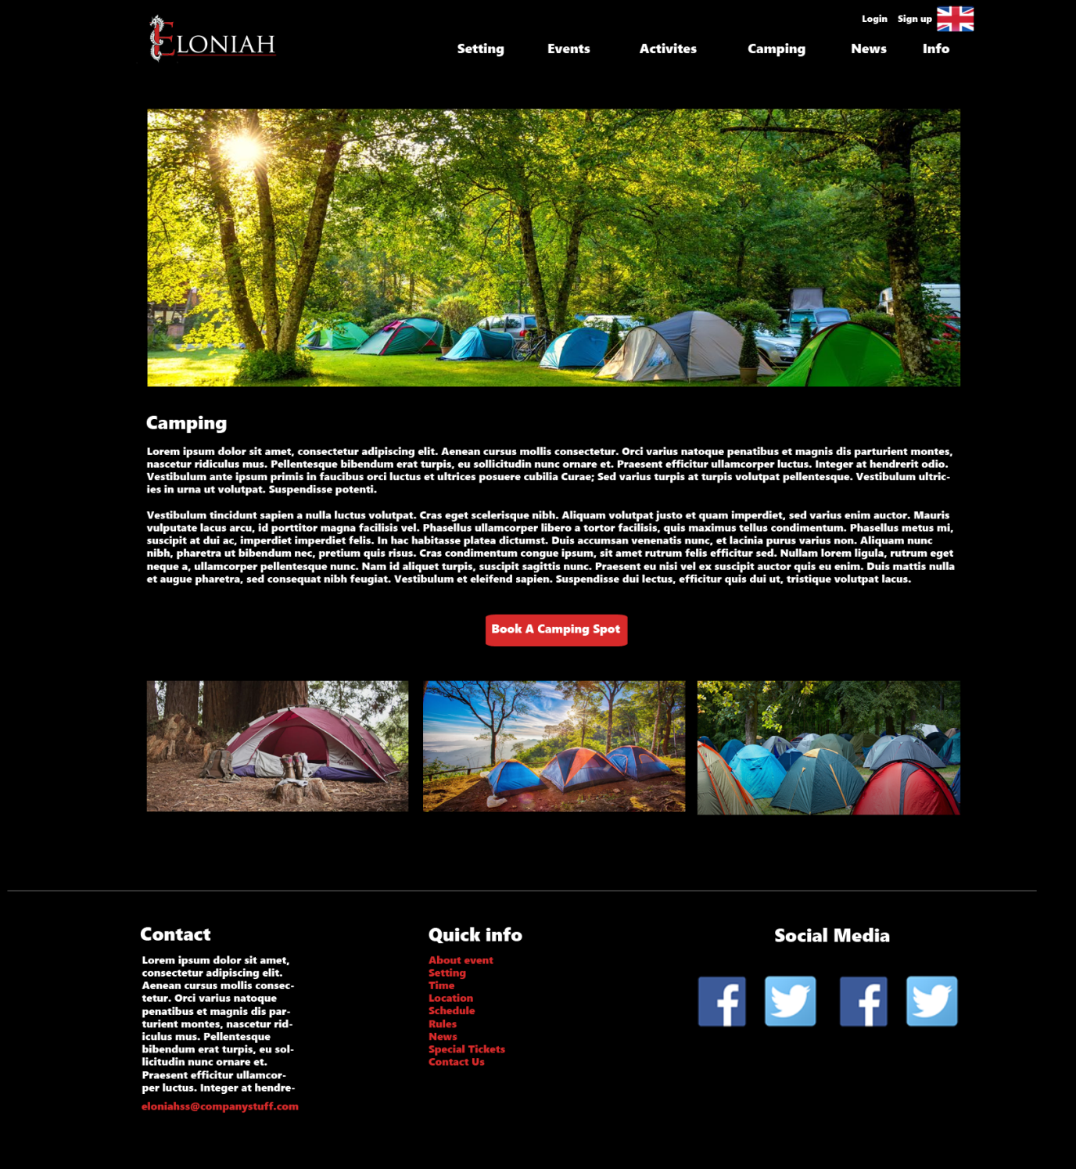

## News page:

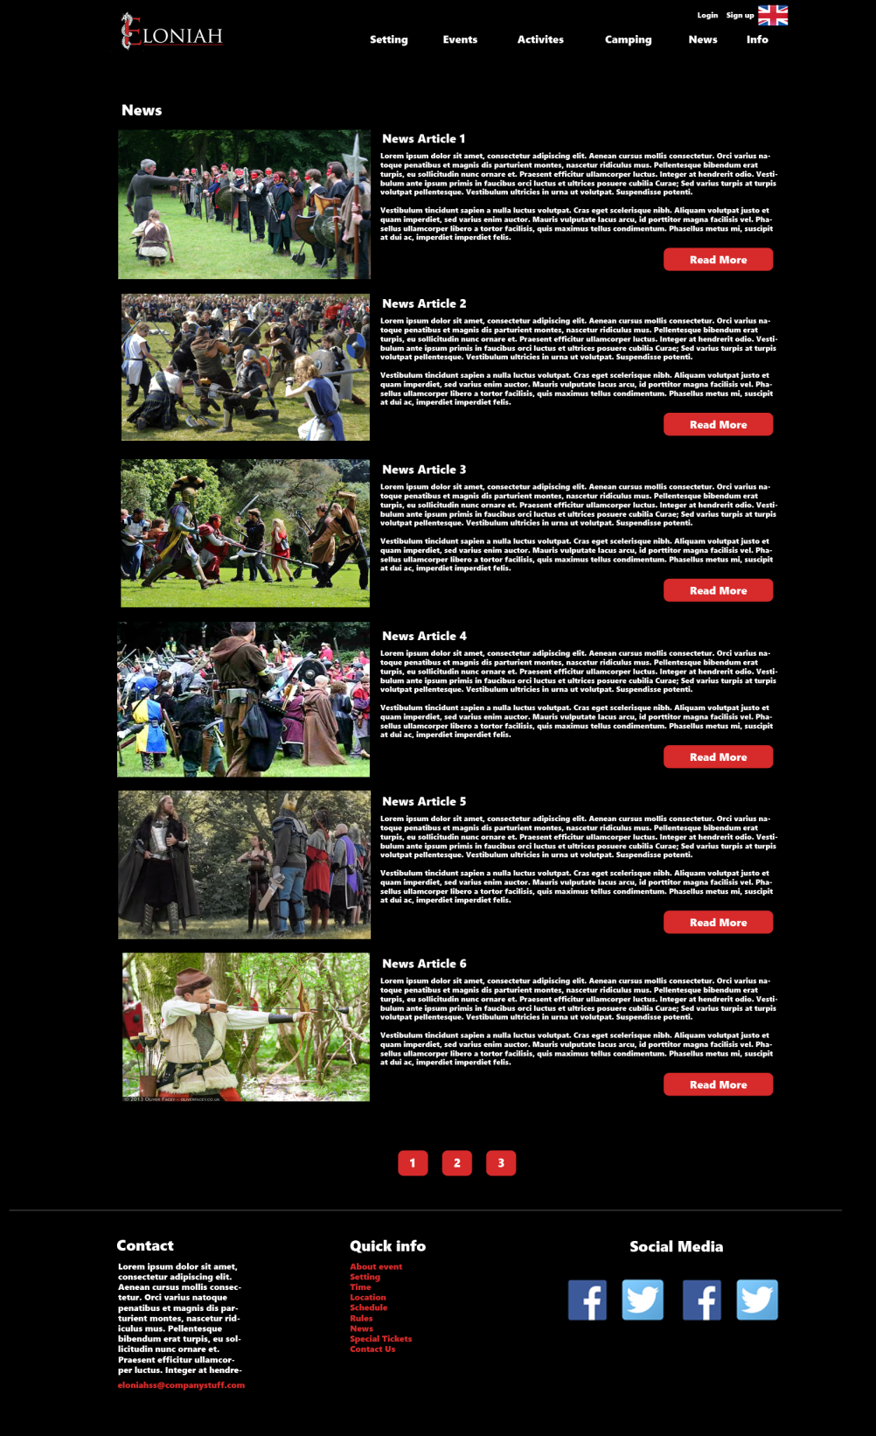

## News – read more:

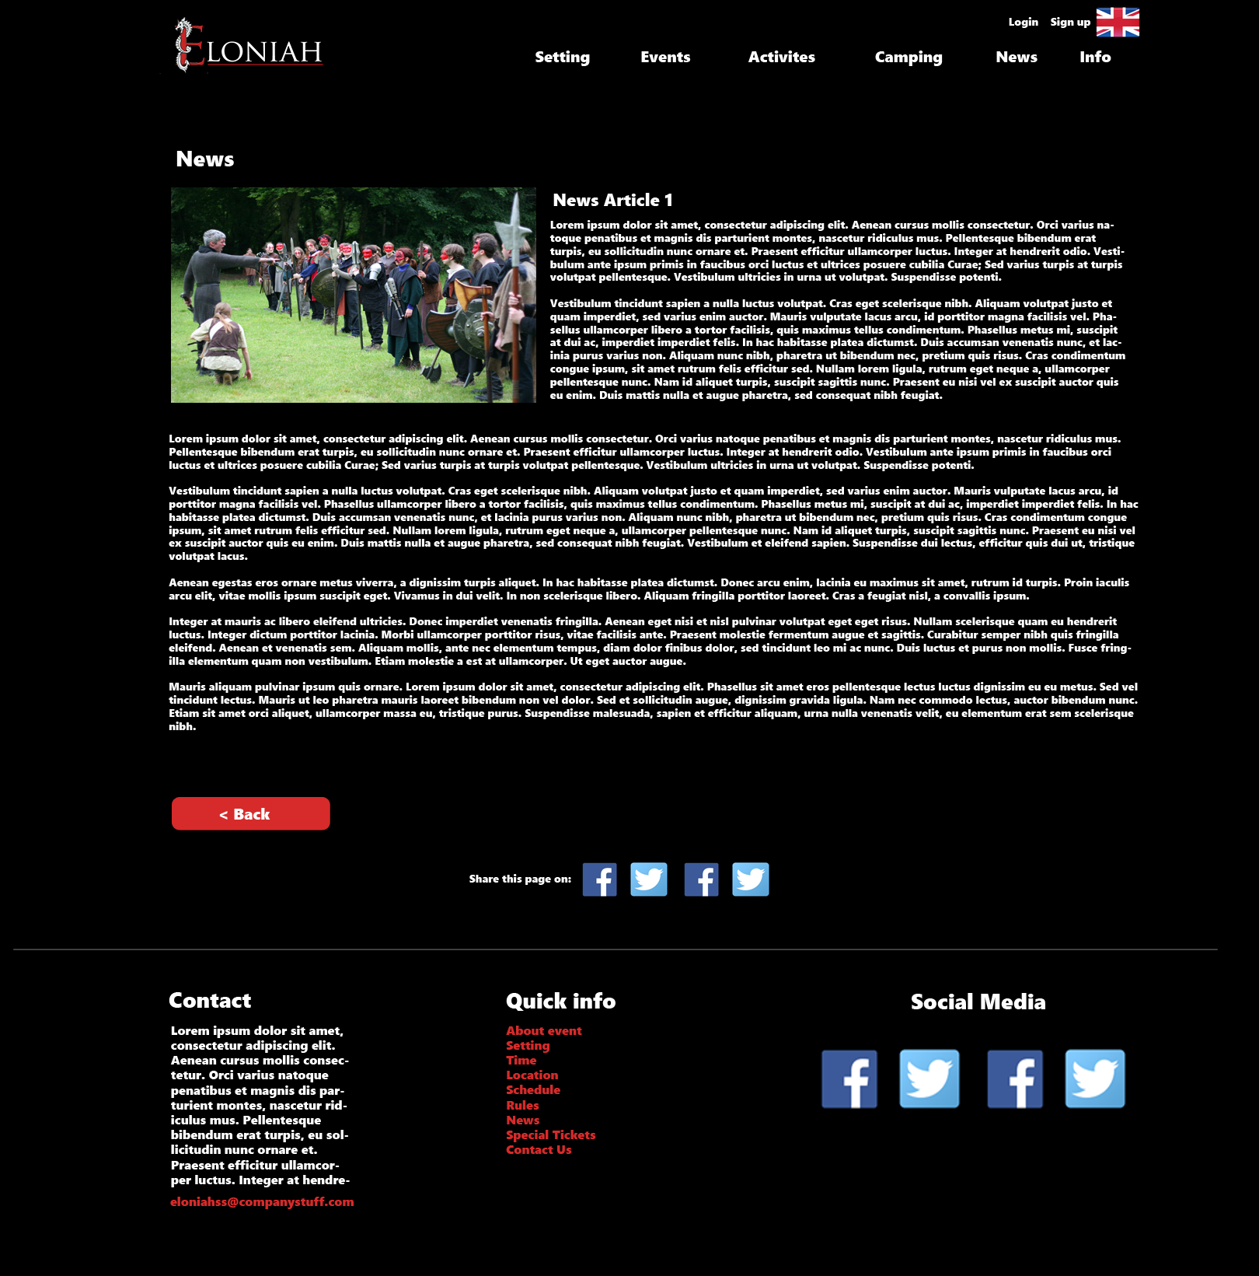

## About page:C:\Users\yenth\AppData\Local\Microsoft\Windows\INetCache\Content.Word\11-Info.png

## Login page:

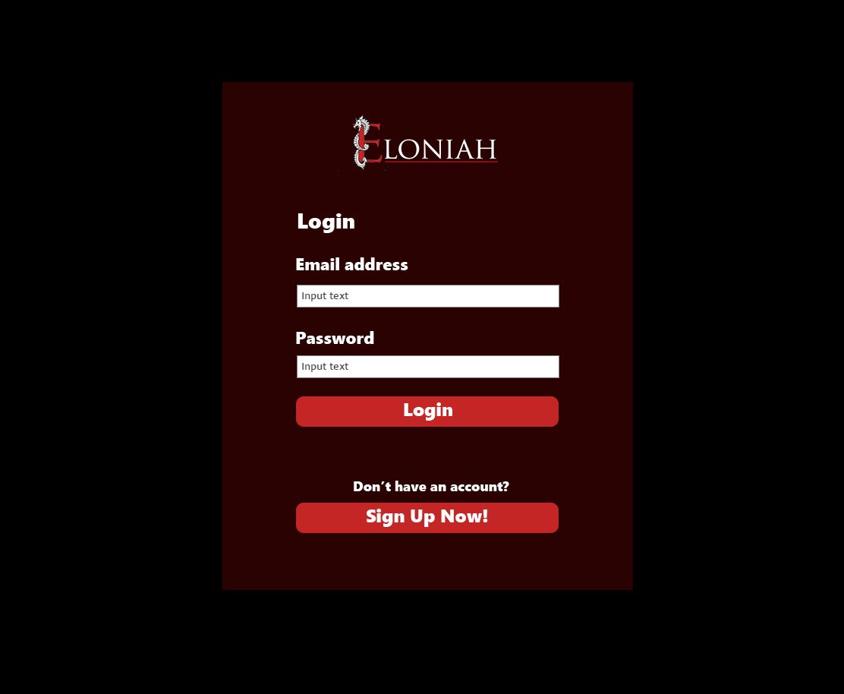

## Sign up page:

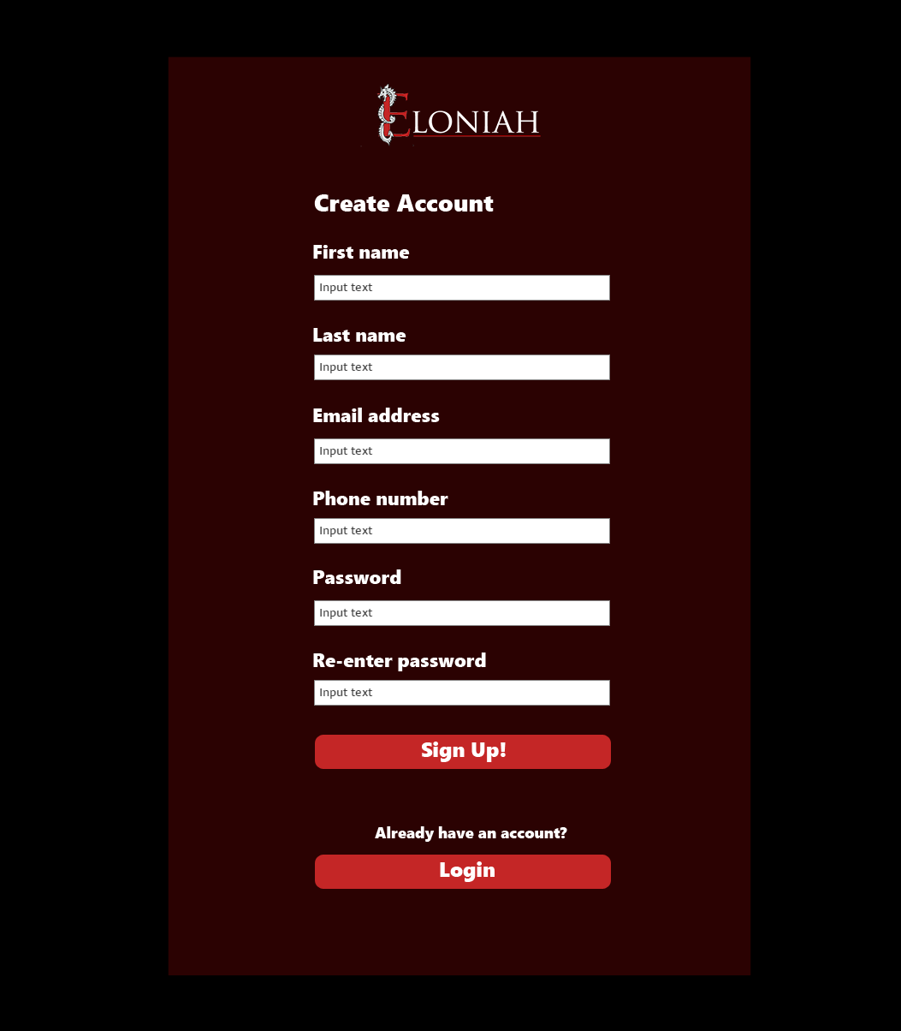

## Participant’s information page

(to show tickets information)

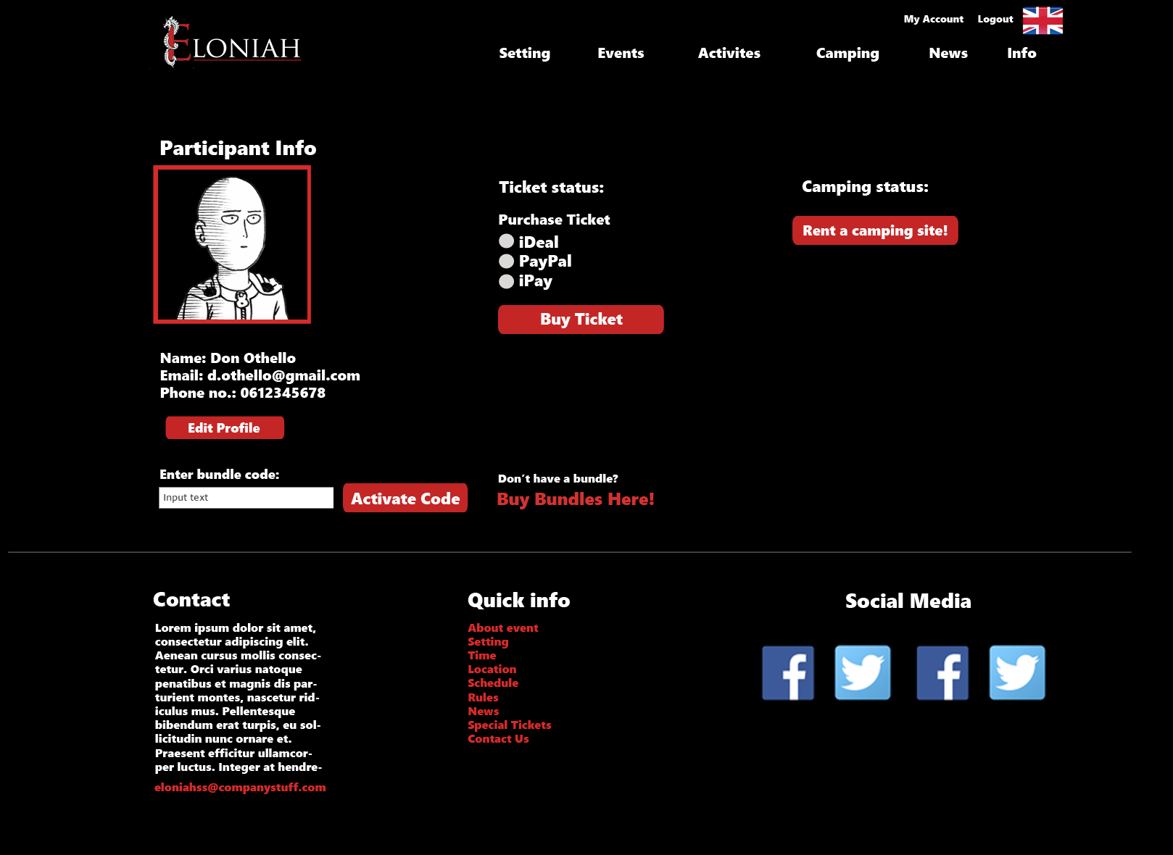

## Participant’s information page

(to show camping information)

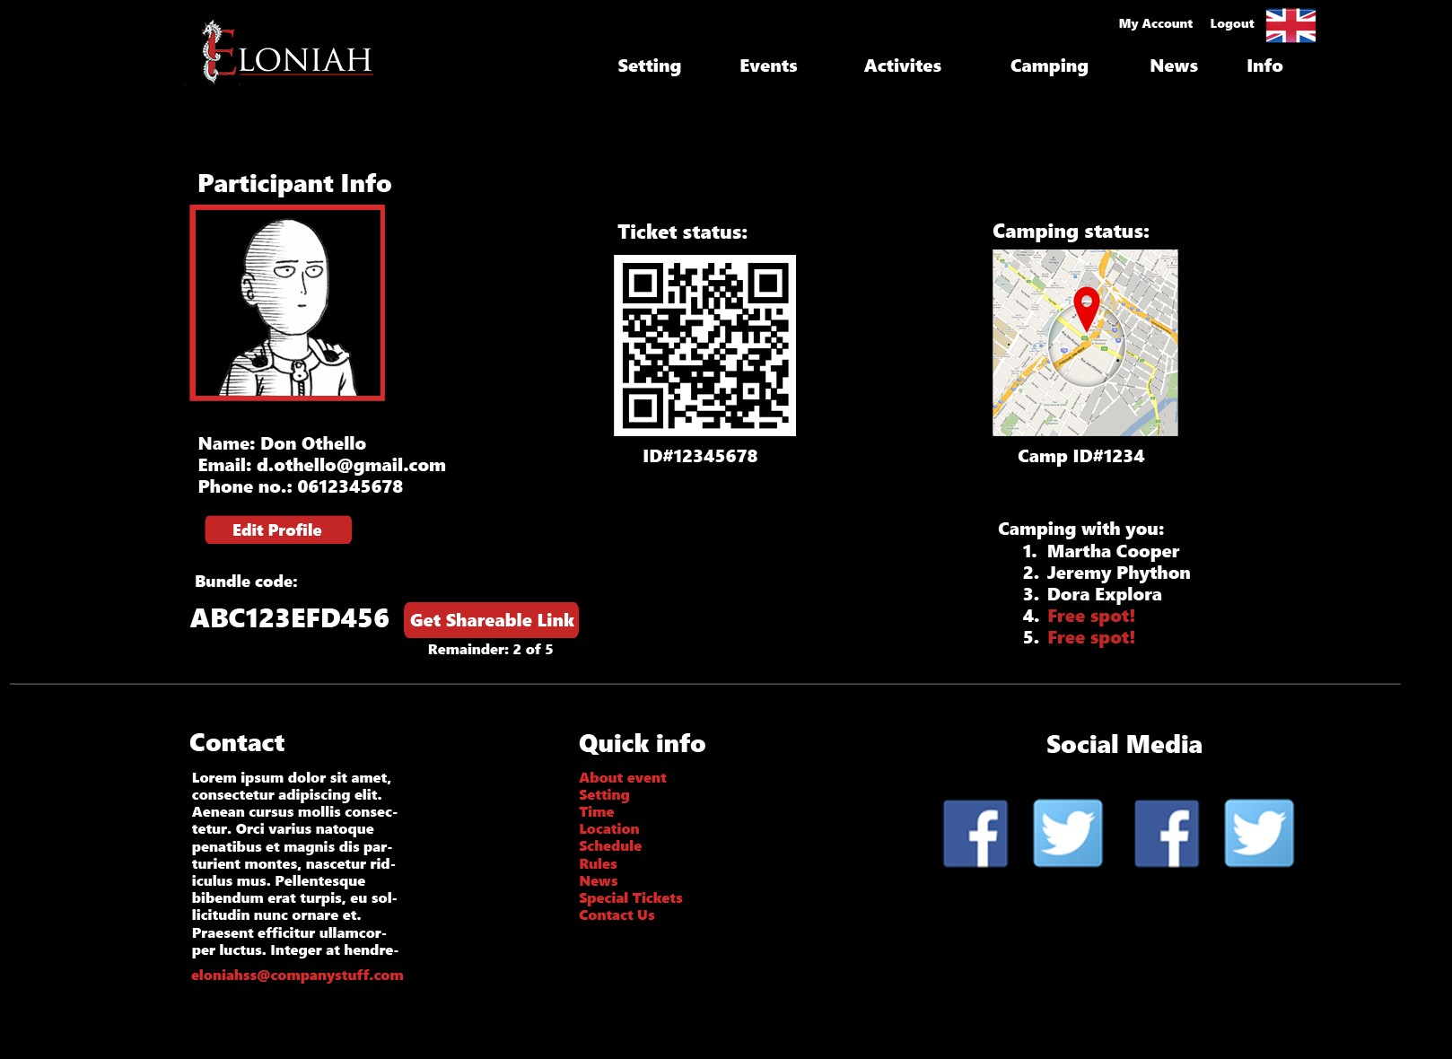

## Camping registration page:

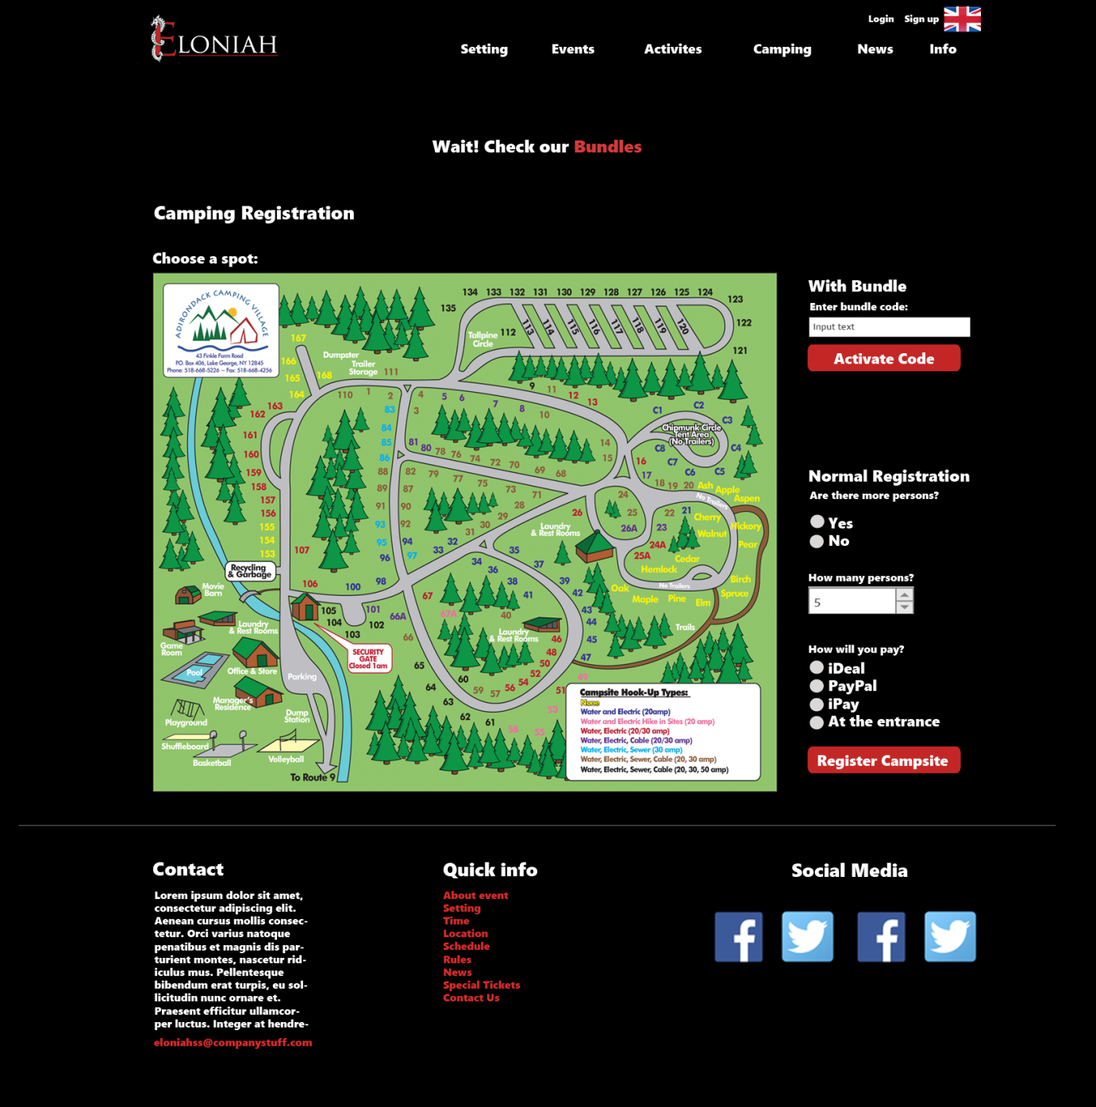

## Bundles page:

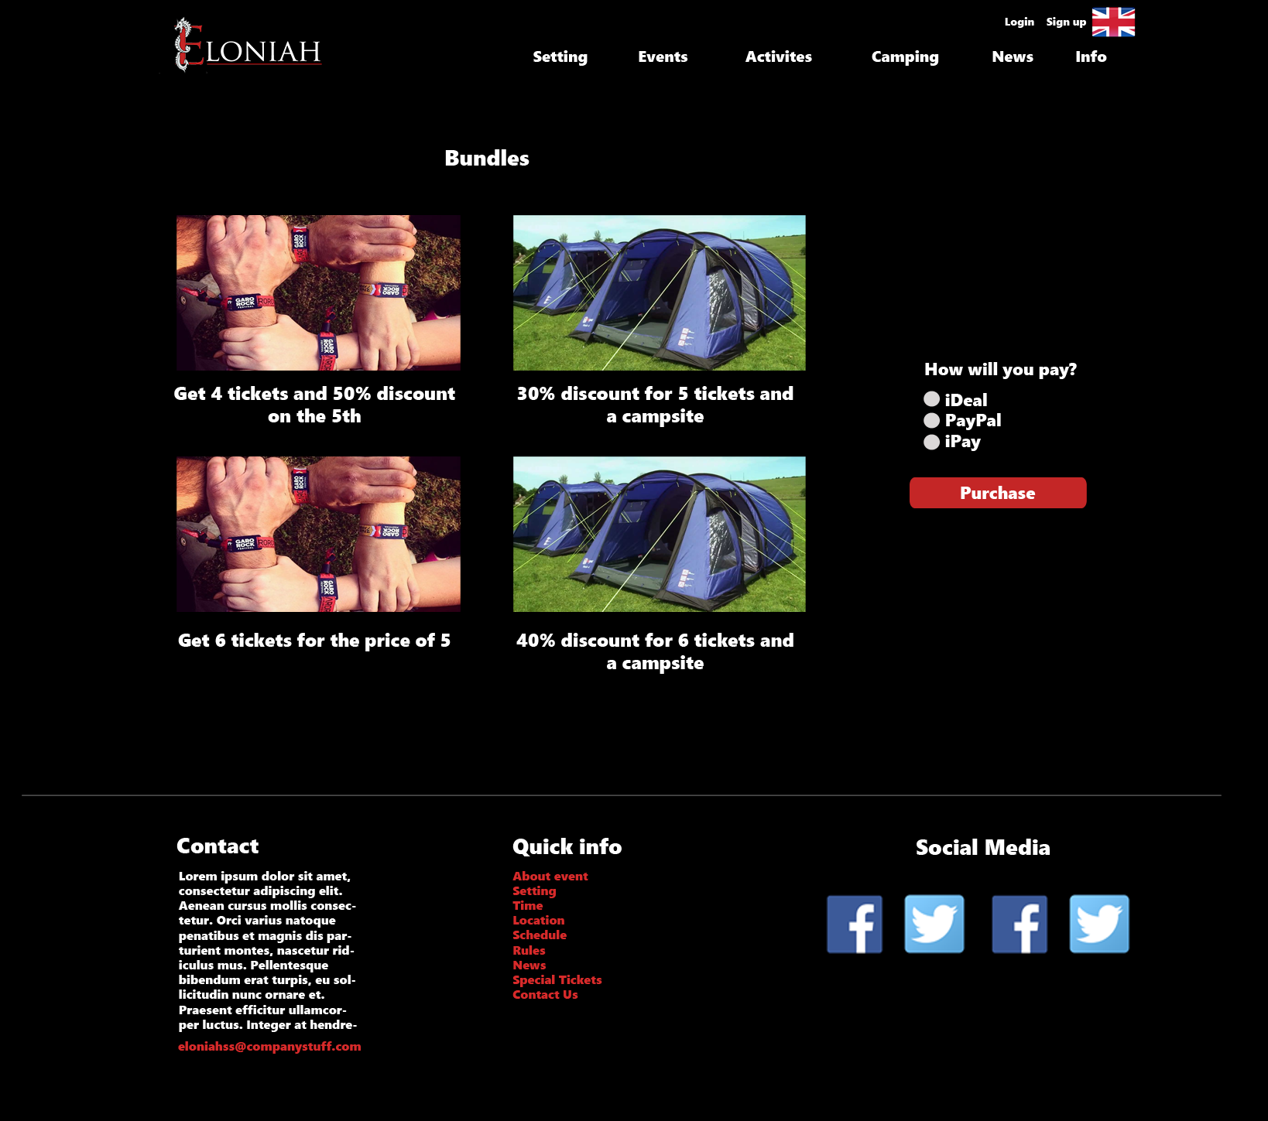

# ERD

* **Red**: The core entities.
* 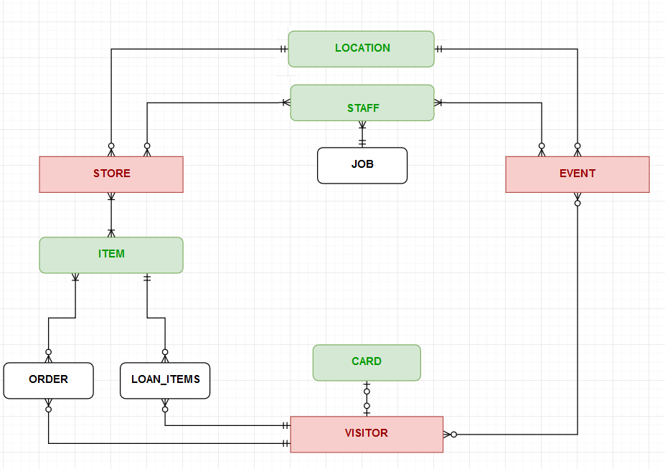**Green**: The entities supporting the core ones.
* **Black**: The entities supporting implementation.